AIM
Create_AP_Payments Attachments
MD.120 deployment Instructions
Raya International Services

Author: Varun Sai Kumar Jonna
Creation Date: JUNE 12, 2024
Last Updated:
Version: 1.0

Title, Subject, Last Updated Date, Reference Number, and Version are marked by a Word Bookmark so that they can be easily reproduced in the header and footer of documents. When you change any of these values, be careful not to accidentally delete the bookmark. You can make bookmarks visible by selecting Tools->Options…View and checking the Bookmarks option in the Show region.

Approvals:
<Approver 1>
<Approver 2>
To add additional approval lines, press [Tab] from the last cell in the table above.
 Copy Number _____
You can delete any elements of this cover page that you do not need for your document. For example, Copy Number is only required if this is a controlled document and you need to track each copy that you distribute.

Document Control

Change Record
3
Date | Author | Version | Change Reference
 |  | Ver 1.0

Reviewers

Name | Position

Distribution

Copy No. | Name | Location
The copy numbers referenced above should be written into the Copy Number space on the cover of each distributed copy. If the document is not controlled, you can delete this table, the Note To Holders, and the Copy Number label from the cover page.

Note To Holders:
If you receive an electronic copy of this document and print it out, please write your name on the equivalent of the cover page, for document control purposes.
If you receive a hard copy of this document, please write your name on the front cover, for document control purposes.
Contents
Document Control iii
Creating Connections For Integration 1
- Creation Of FTP Adapter. 1
- Creation Of REST Adapter 6
- Creation Of SOAP Adapter 7
Creating Integration 7
Run The Integration 34
Integration Tracking 35
Open and Closed Issues for this Deliverable 37
Open Issues 37
Closed Issues 37

To update the table of contents, put the cursor anywhere in the table and press [F9]. To change the number of levels displayed, select the menu option Insert->Index and Tables, make sure the Table of Contents tab is active, and change the Number of Levels to a new value.

Create Connections for Create_APPAYMENTS_Attachments
Creation of Adapters:
- For Create AP Payment Attachment we are using Three connections FTP, REST and SOAP
- To create connections, navigate to connections tab and select create option then select desired adapter.
Adapter :- it helps to store the required credentials to make a connection.

Creation of FTP :
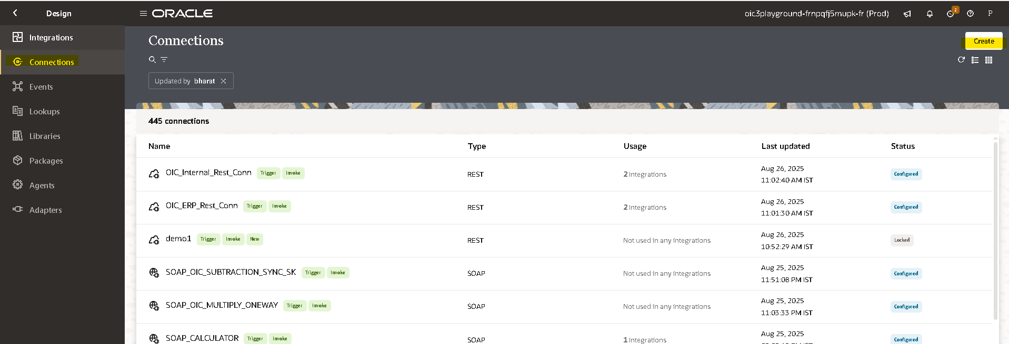
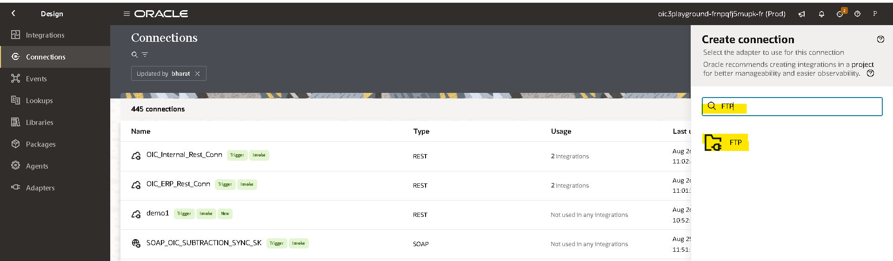
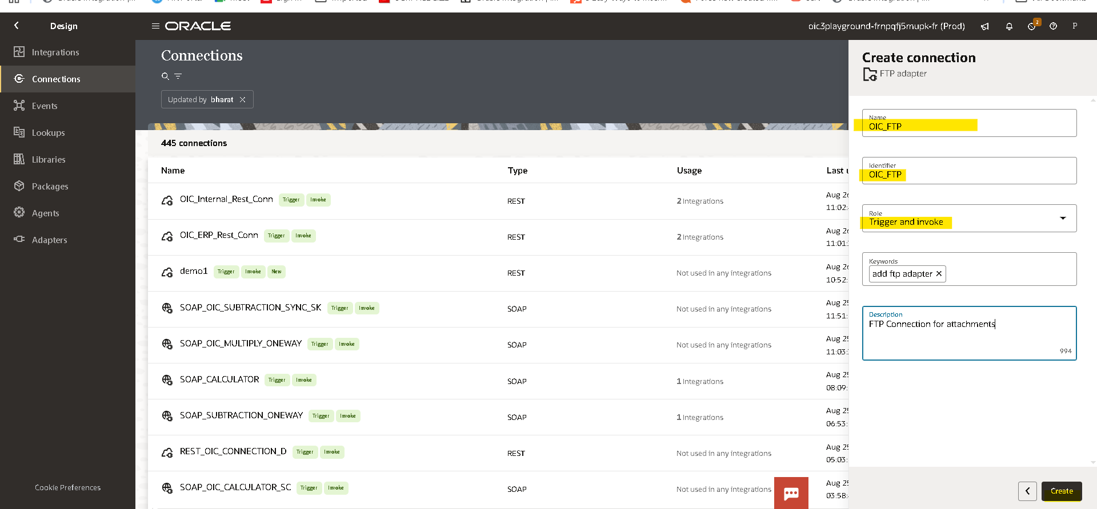

Connection Role :- A trigger means the connection where the integration receives the message from. An invoke means the connection where the integration sends the message to.
- Based on our requirement we choose trigger and invoke role connection
- After clicking on create we need to pass the required credentials as shown below
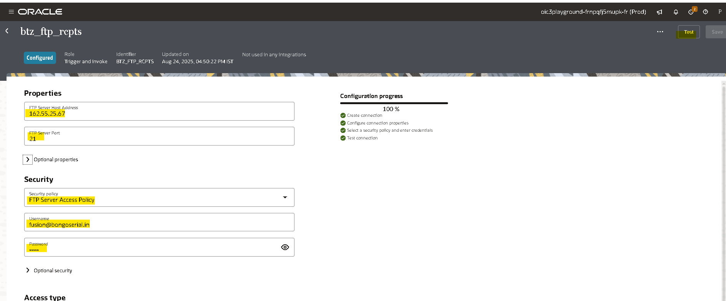
- Then click on test,popup will appear as shown above then select diagnose & test.
- After successful testing save your connection.
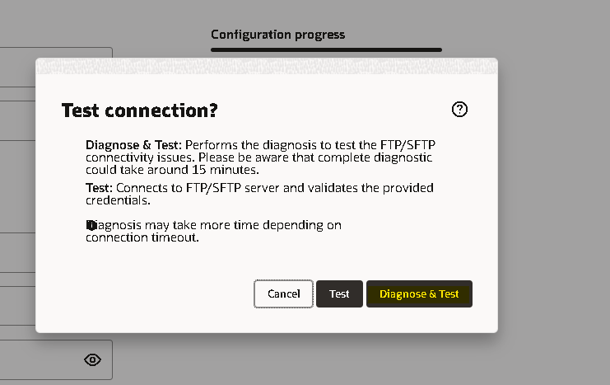
Creation of REST Connection:- role trigger and invoke
- Here 2 REST connections are required.
- Navigate to connections tab then select the adapter based on the connection(rest)
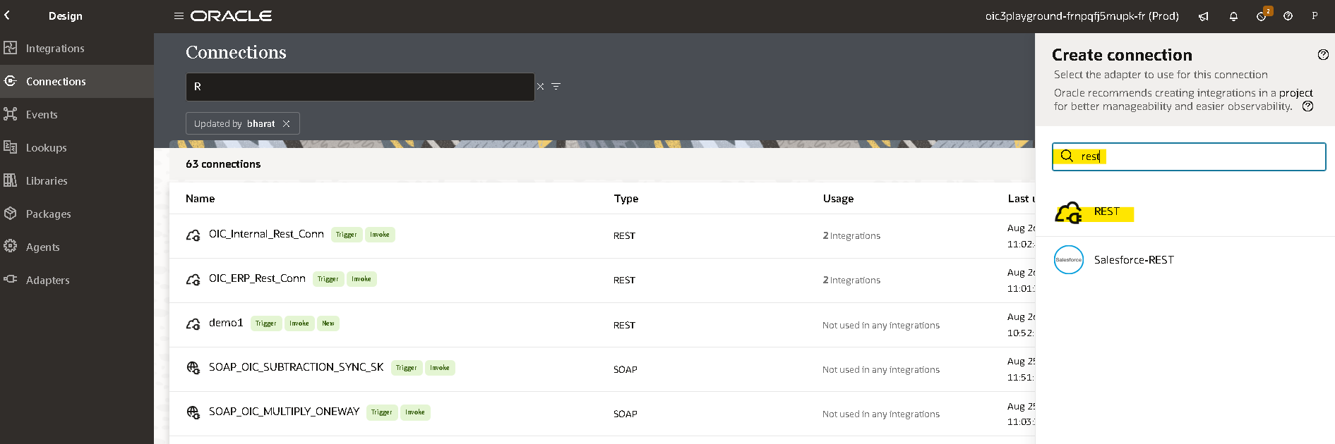
- Select connection type as rest api base url.
- Enter fusion base url as connection url.
- Select security as basic authentication and enter fusion credentails as username and password.
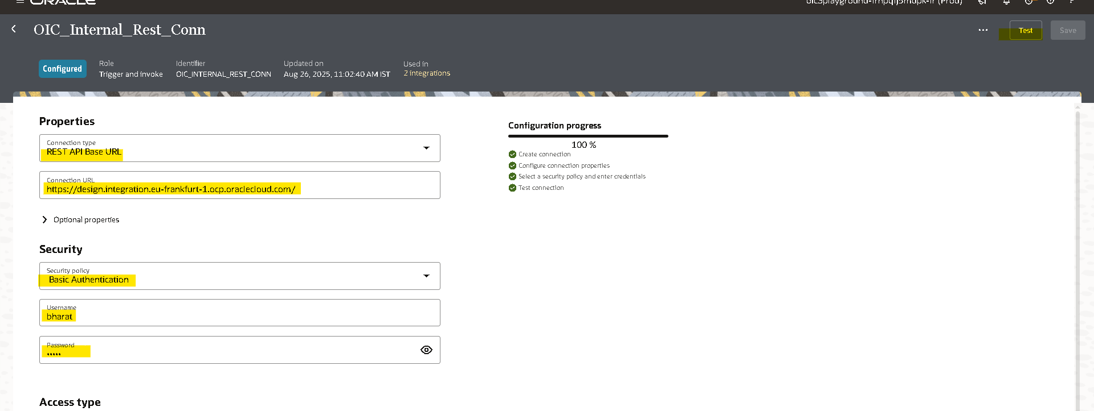
- Then click on test, after testing successfully save the connection.
Creation of SOAP Connection:- role trigger and invoke
- Navigate to connections tab then select the adapter based on the connection(rest)
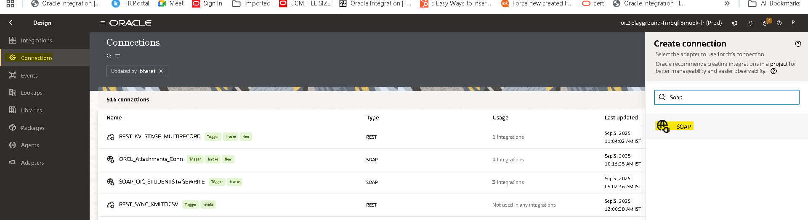
- In WSDL url field enter the complete URL of fusion along with extension of WSDL to upload Attachments.
  - <Fusion URL>/fscmService/ErpObjectAttachmentService?WSDL
- Select security as basic authentication or user name and password and enter fusion credentails as username and password.
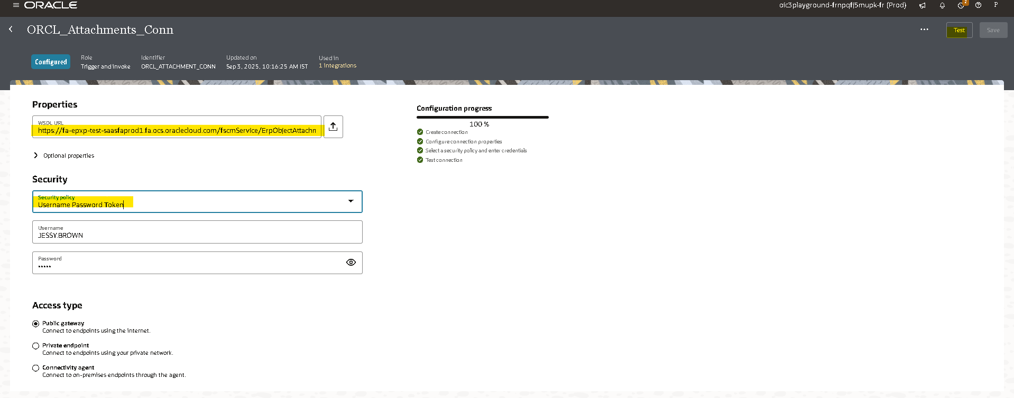
- Then click on test,popup will appear as shown above then select Validate & test.
- After successful testing save your connection.

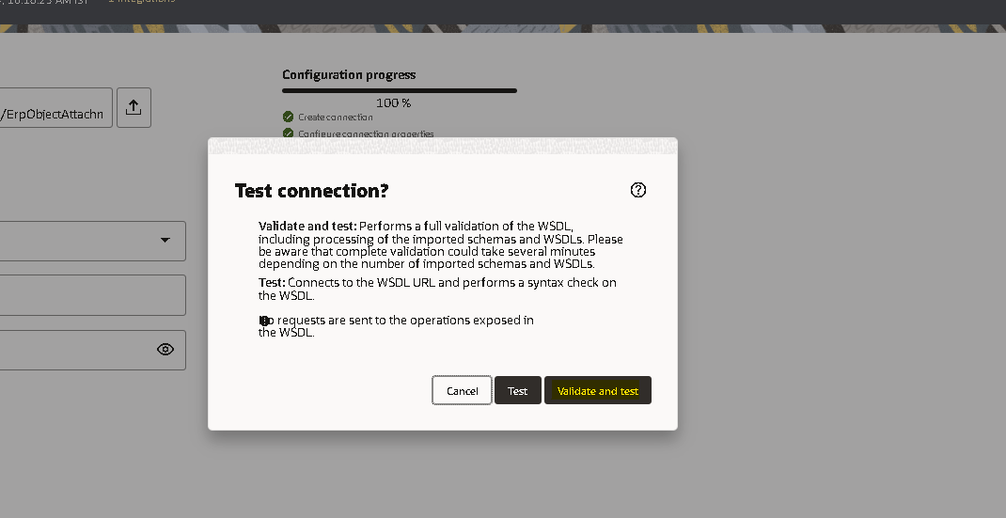

Creation of Integration:
- Navigate to integration tab then click on create option and select Application.
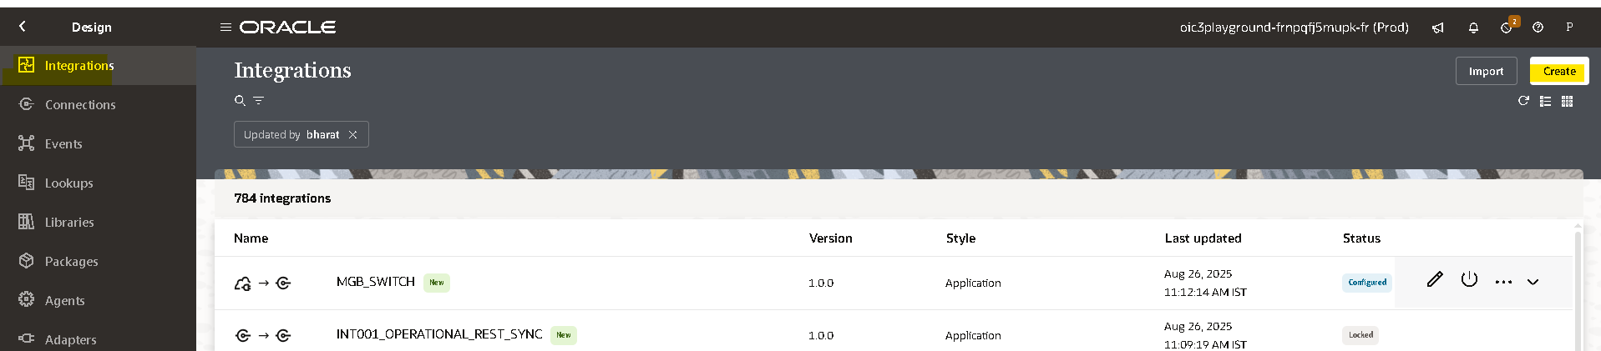
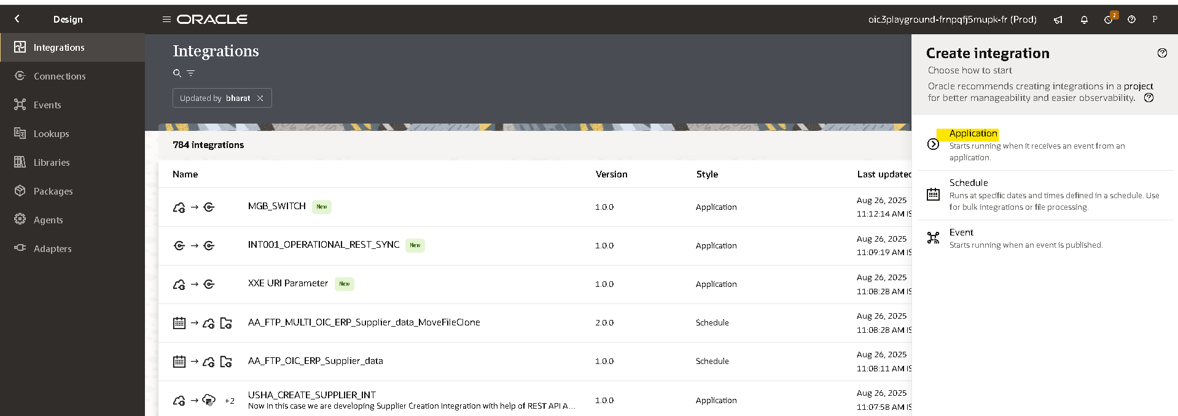

- Try to create with a unique name for identification.
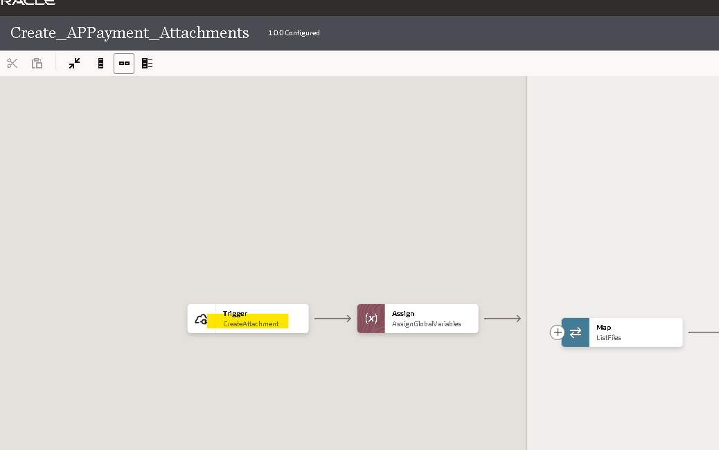
- Choose the REST endpoint connection(OIC_Internal_Rest_Conn) which was created in the above steps.
- Provide a name for the REST Endpoint.
- Provide an endpoint relative resource URL.
- Choose the action to perform as POST and select configure a request payload for this endpoint.
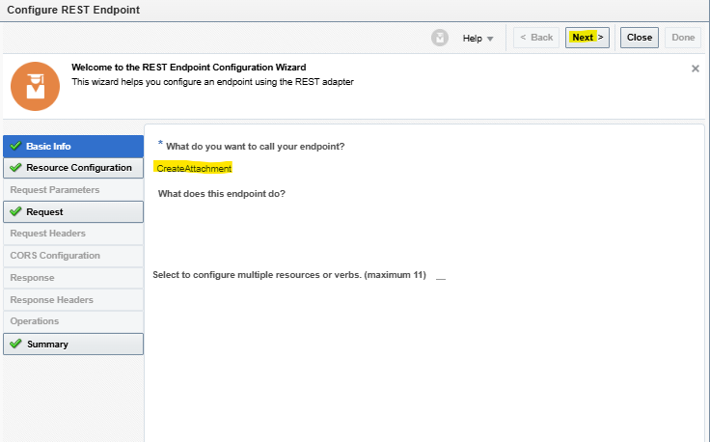
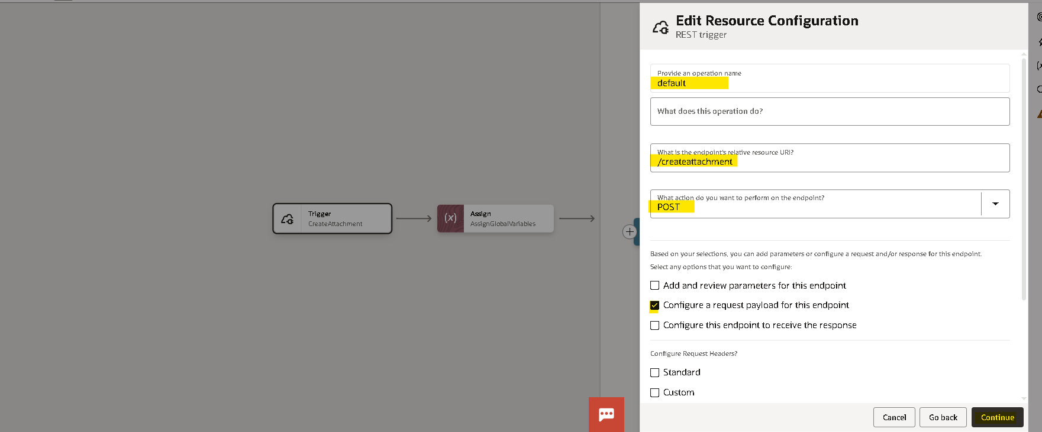
- Now select request payload format as JSON and enter a sample JSON by clicking on inline.
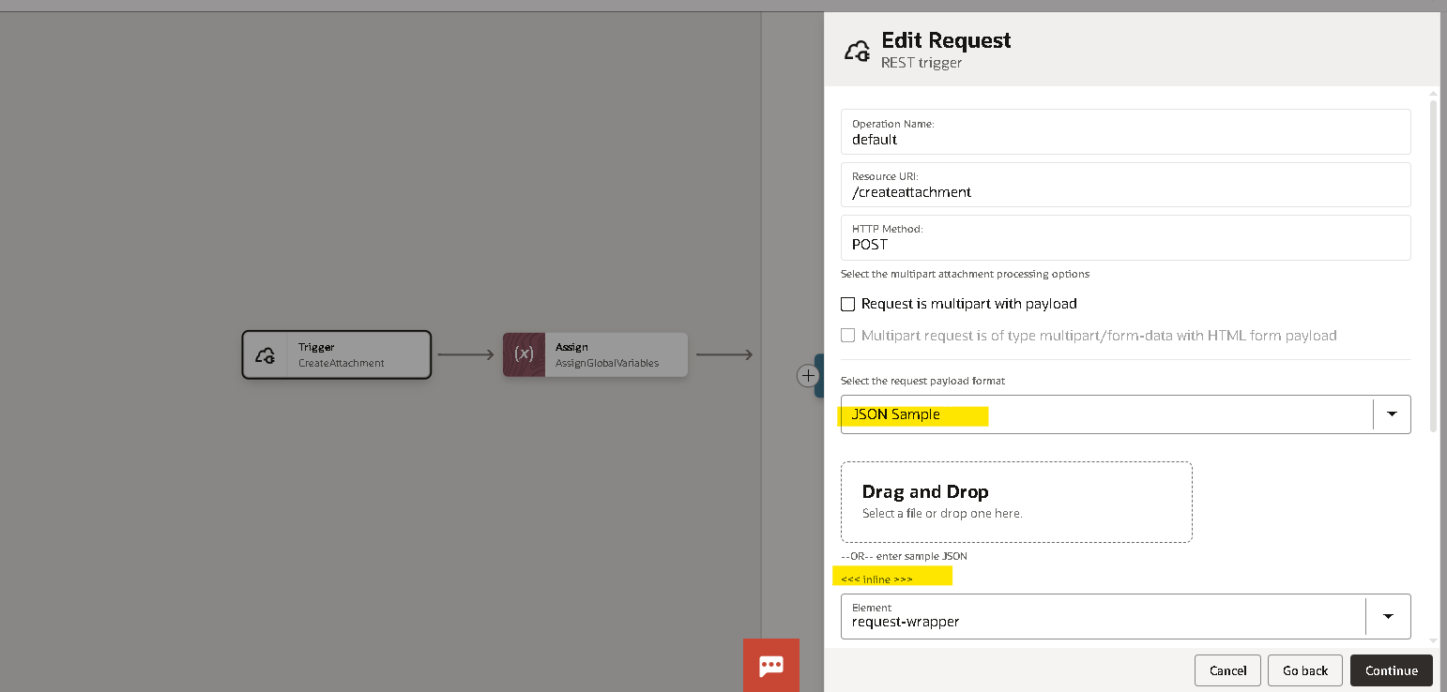
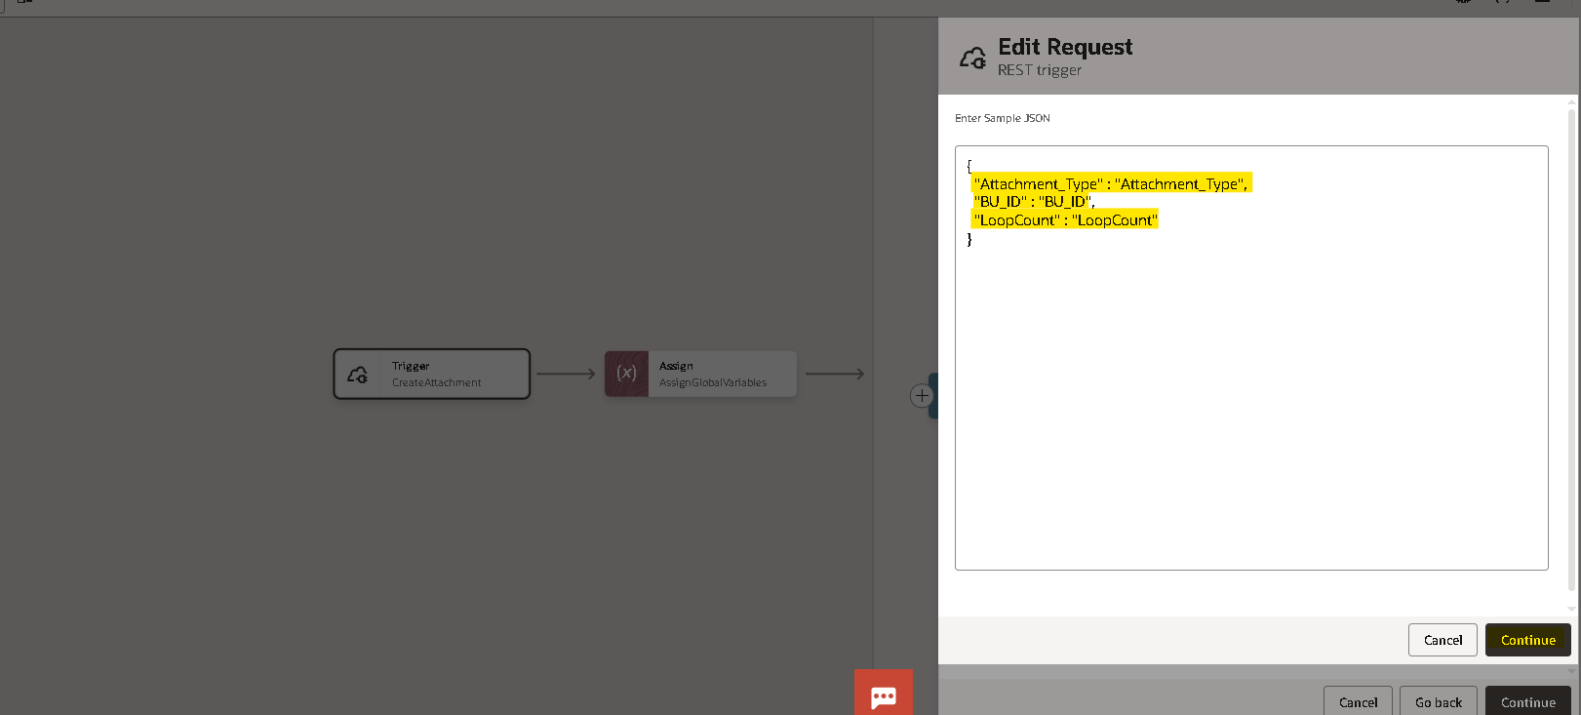

- Once the integration is created select the action button on the right side of the tab.
- Drag the assign action and place it on plus (+) icon in the integration.
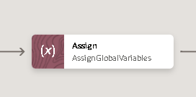

- Give a name for the assign action and click on create.
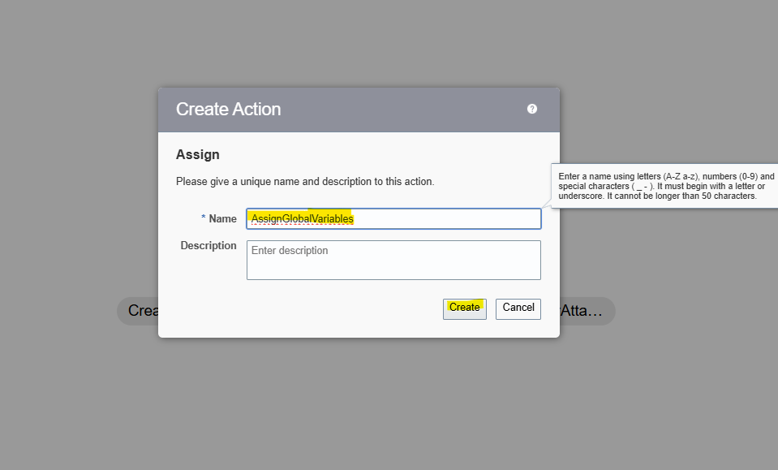
- Give the name of the variable and click on the pencil icon to assign the value for the variable.
- To add one more variable you can select plus (+) icon.
Note :- to assign/mention the values we need to use single quotes .
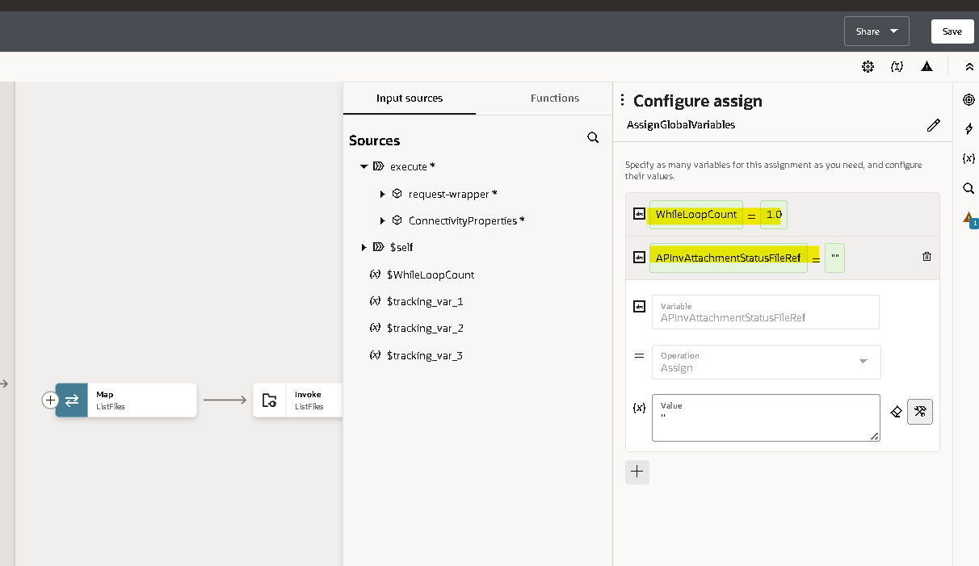

- Here we created 2 variables.
- WhileLoopCount : for providing while condition.
- APInvAttachmentStatusFileRef: to store the AR Receipt Attachment Status file reference.
- Now create a While Loop by dragging and dropping the While after AssignGlobalVariables.
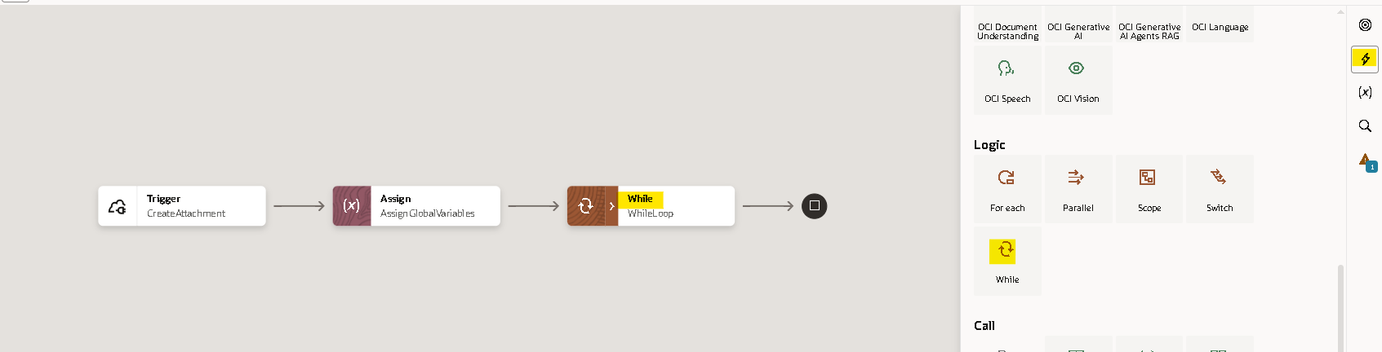

- Now drag and drop WhileLoopCount variable from inputs section and Count from request-wrapper into above and below boxes of condition respectively. Give condition as less than or equal to.
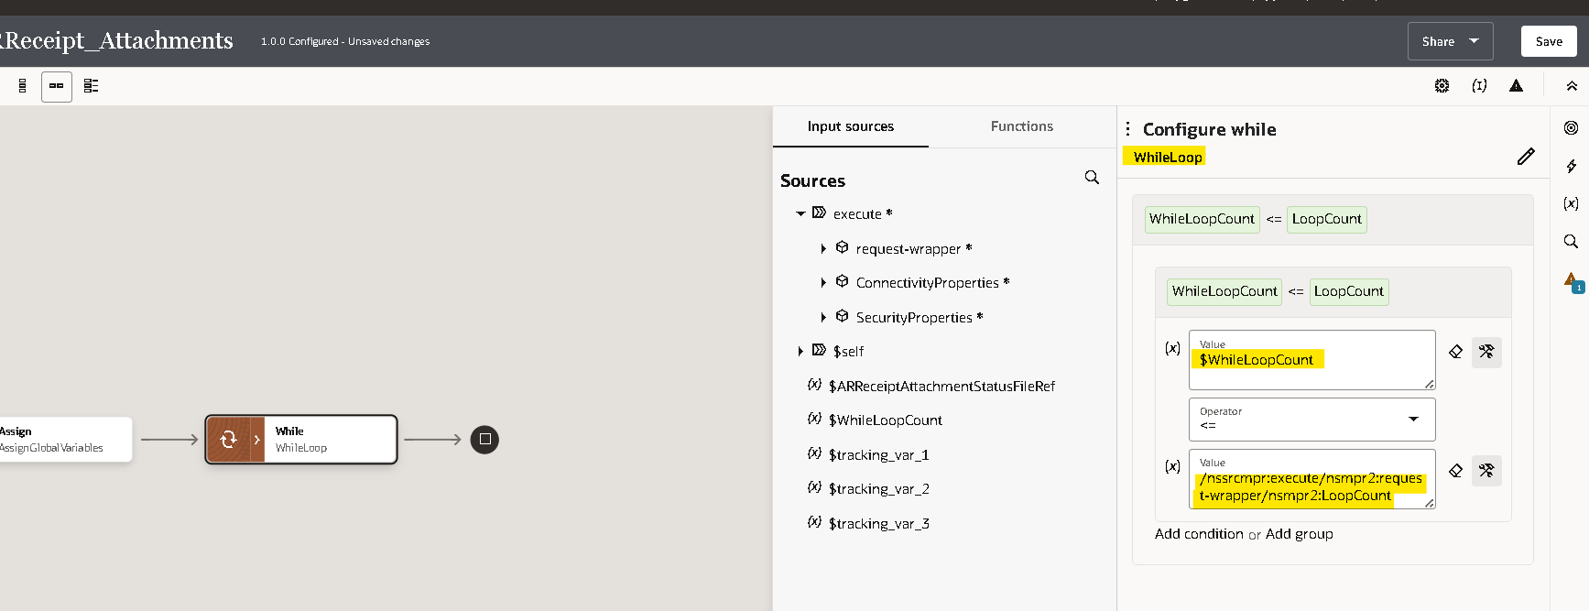

- Select the plus (+) icon and select the FTP adapter which we created earlier.
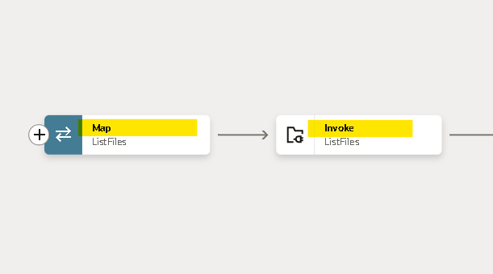

- Name the FTP connection appropriate to your integration for better understanding. As we are listing the number of files in source dir, so we used the list_files operation.

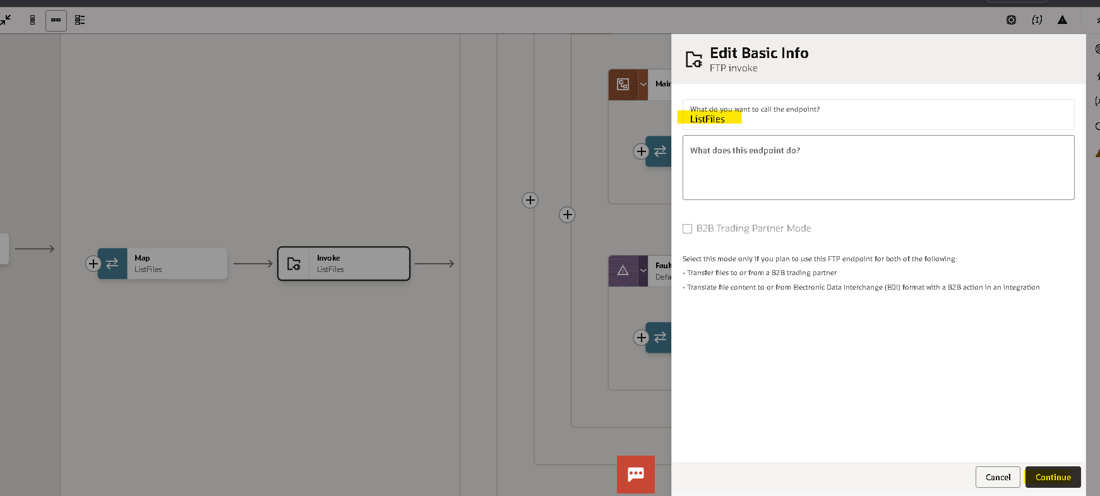
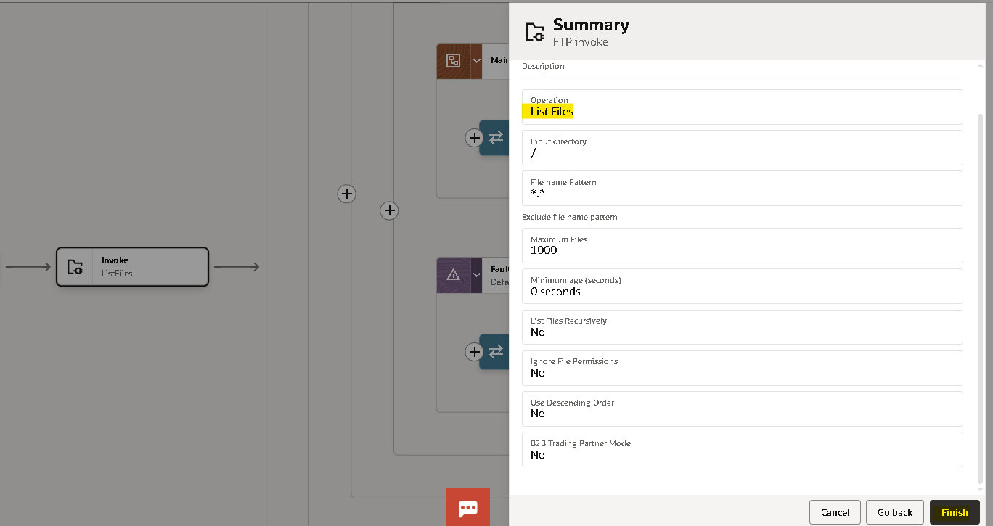
- Since we are using variables for input directory, temporarily mentioned ‘/’ and’ *’ symbols.
- Then click Next and Done to create FTP connection.
- Then it will create a mapper as shown below
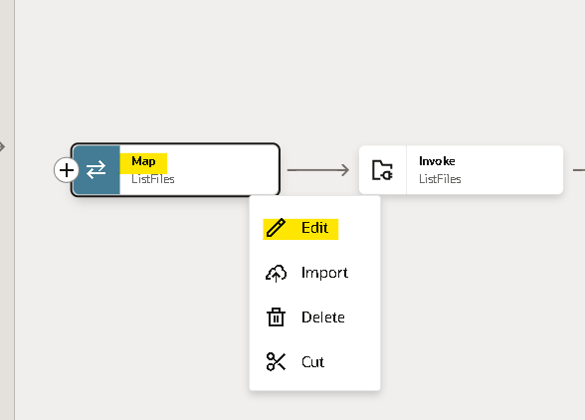
- We need to map the data for the list operation as a request
- We need to create a target node if we need to map the data manually as per our requirement.
- Click on XSLT.
- Here we are listing every file from the directory so we will use asterisk (*) for the filenamepattern using single quotes as
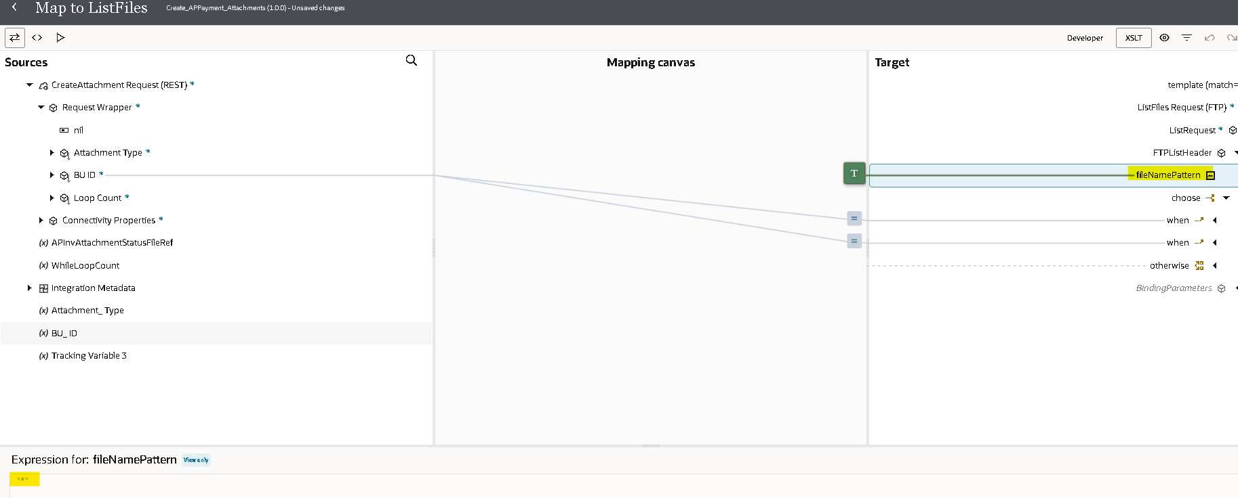
- Now use XSLT functions Choose, When and Otherwise as shown below. This is done to use different directories for each BU_ID.
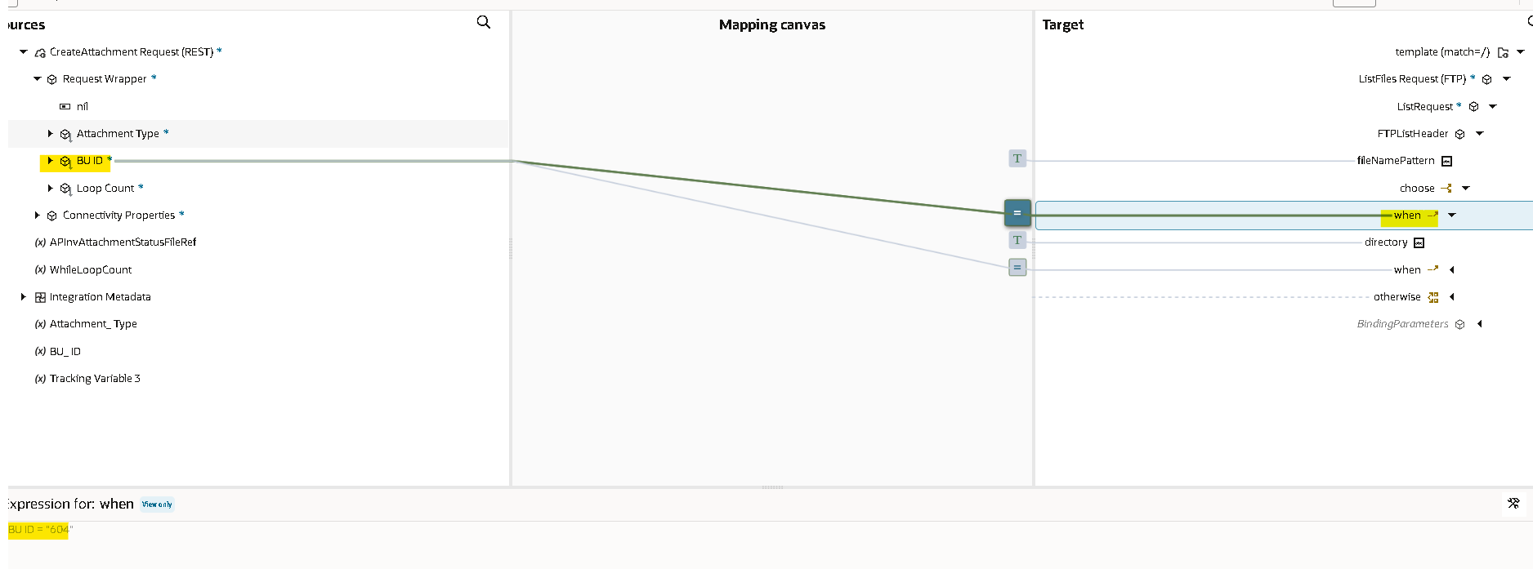
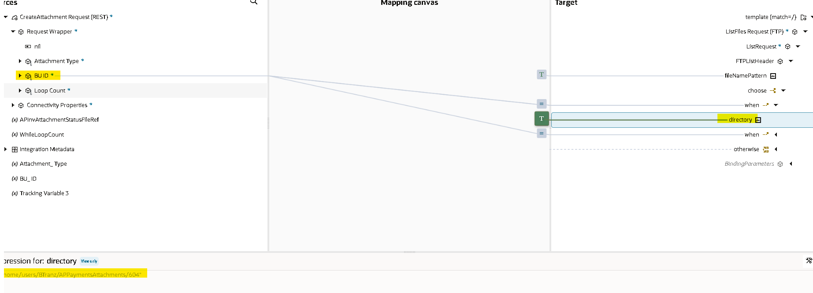
- Similarly, repeat the process for other BU_IDs by using When and Otherwise.

- Now we are using switch operation to check whether file exists or not in the listed directory.
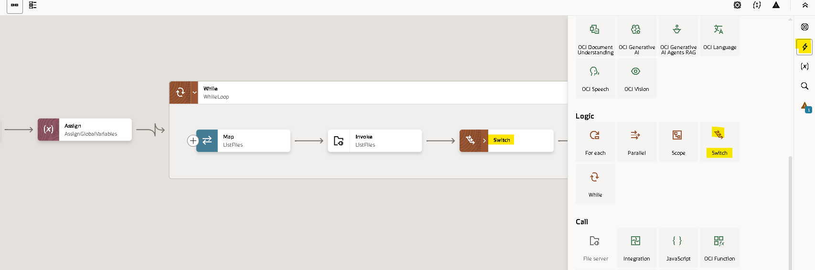

- Once you drag the switch operation on the plus (+) icon
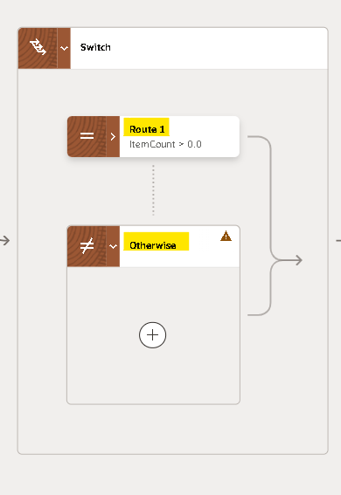
- We will use the response of the listfile operation using itemcount.
- Drag the itemcount from the listresponse to the switch condition as shown below.

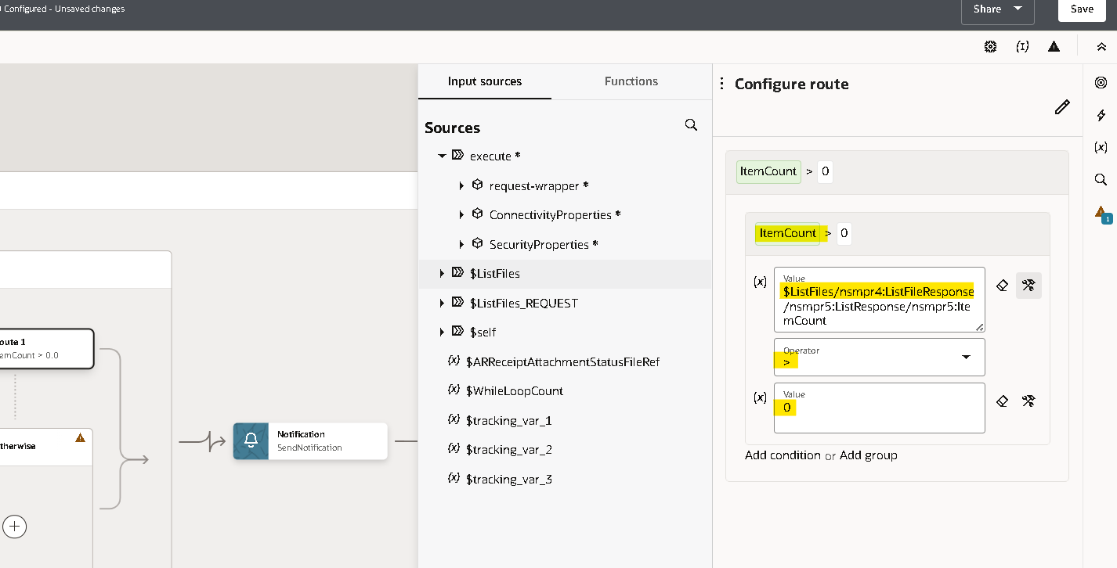

- Now we need to use for each action as we need to iterate each file.
- Click on plus (+) icon and search for each as shown below.
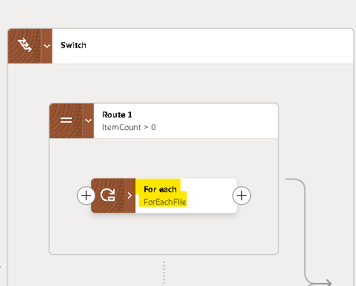
- We will use the repeating element as the file which we got as a response from the list file operation.
- Drag the file to the repeating element and give a name for Current Element Name, click on create.
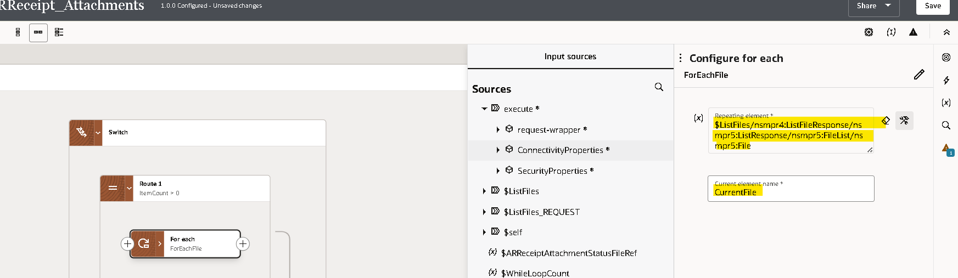

- Scope: - it is a logical container or grouping mechanism used to organize and control the flow of integration components and actions within integration.
- We need to add a scope as we can handle any errors within scope without disturbing whole integration.
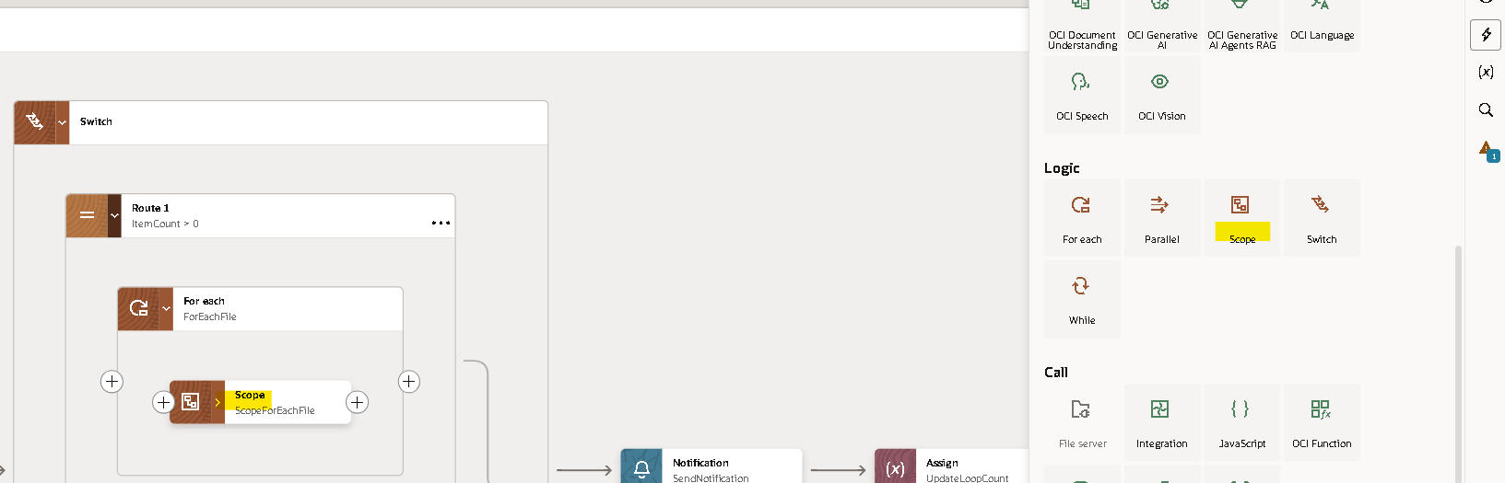

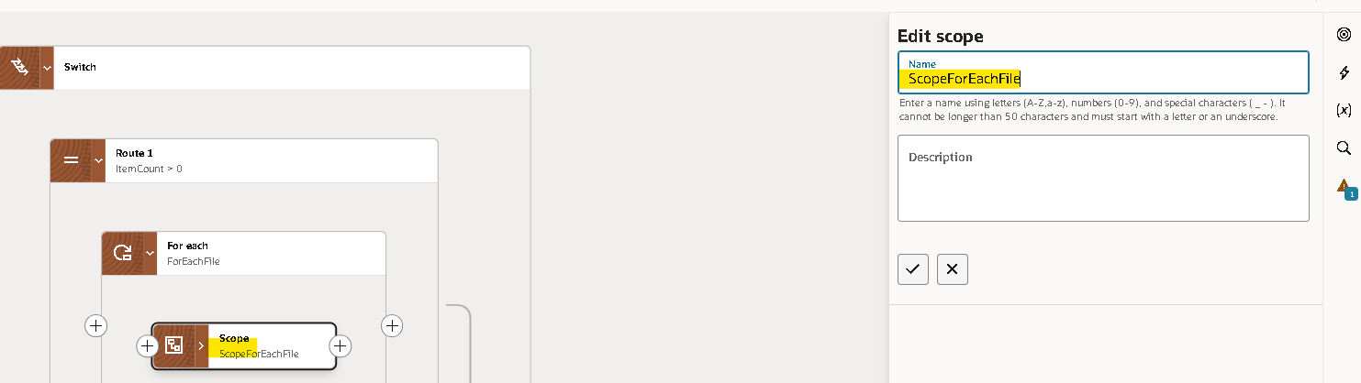
- Within the scope we are using download operation of the FTP connection
- The download operation allows us to download the file in OIC logical directory. It is the virtual directory which can only be used within that integration
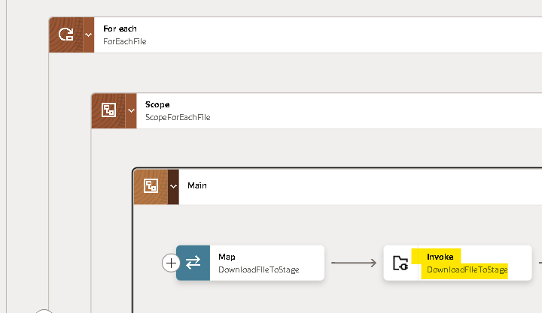

- We will map the input directory and file name later with the response of the ForEach. As of now we are assigning it as shown below
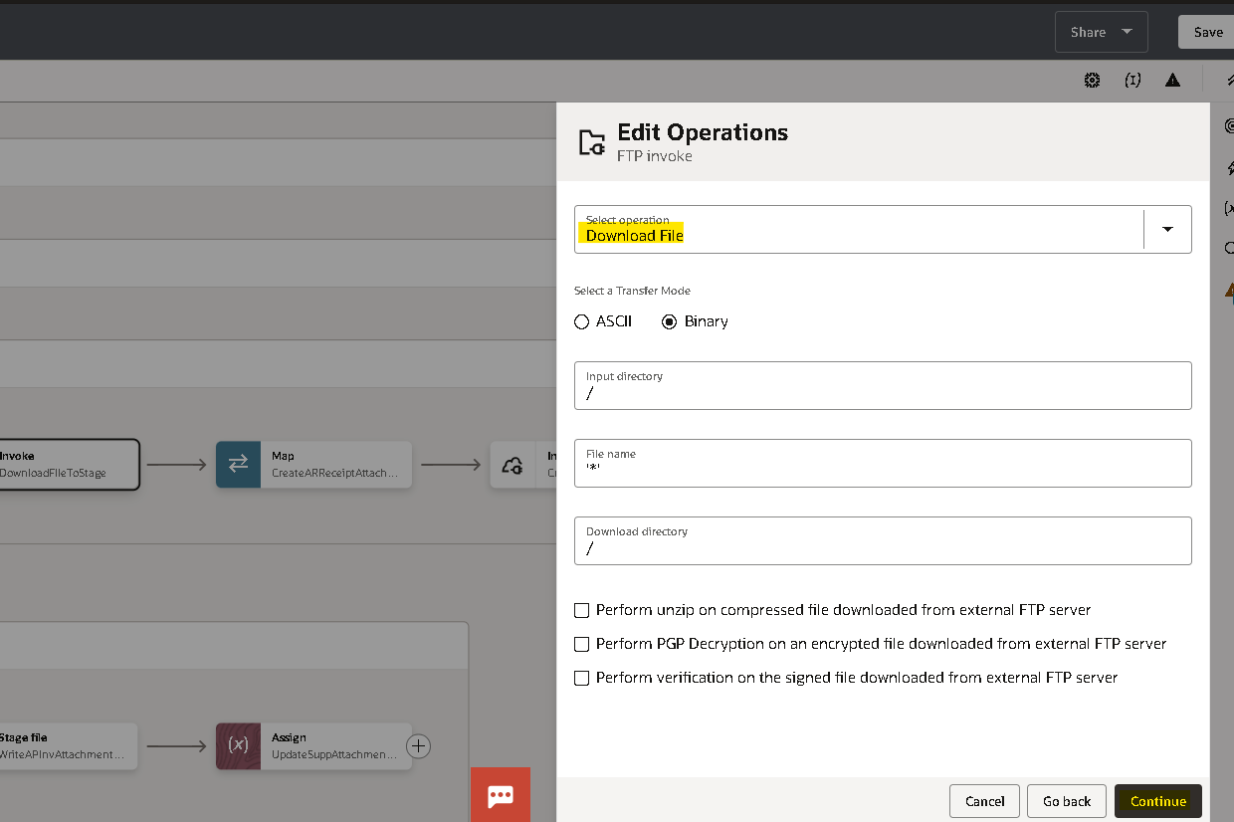
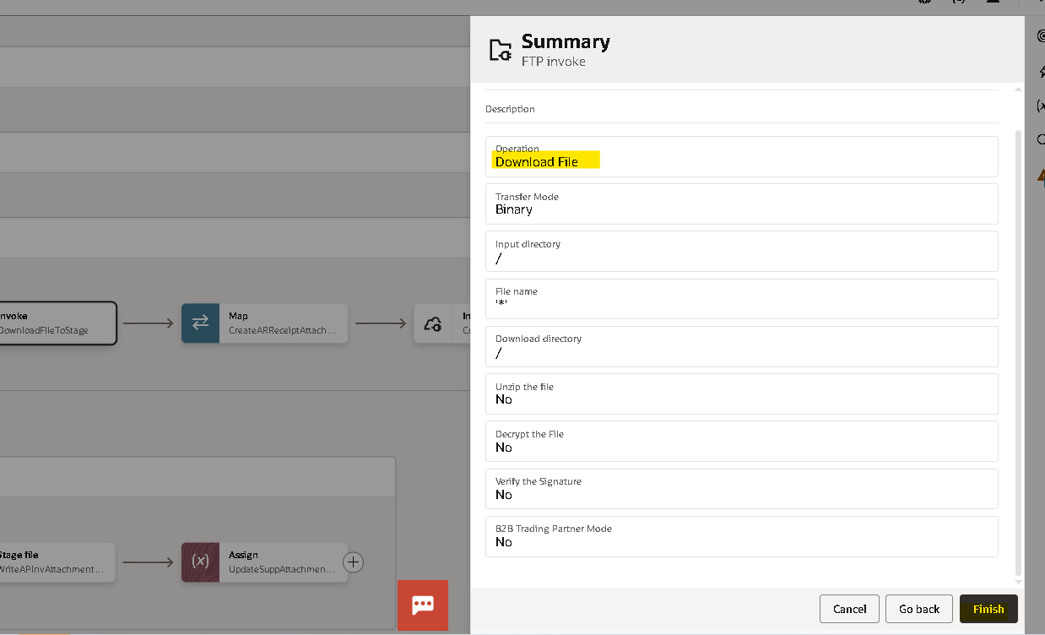
- Click on edit icon on the mapper of the download file operation and map the values.
- For the file name and the directory, we are using the current source file which is the ForEach response.
- For download directory (OIC logical directory), we are creating a target node and in expression we are using the filename here we are using the substring before function to remove the extension and returns only file name.
- Drag the substring-before option from the toggle function option from the top right corner.
- Drag the filename from the current source file and hardcode the ‘.’ as it returns the string before the dot (.) And then validate.
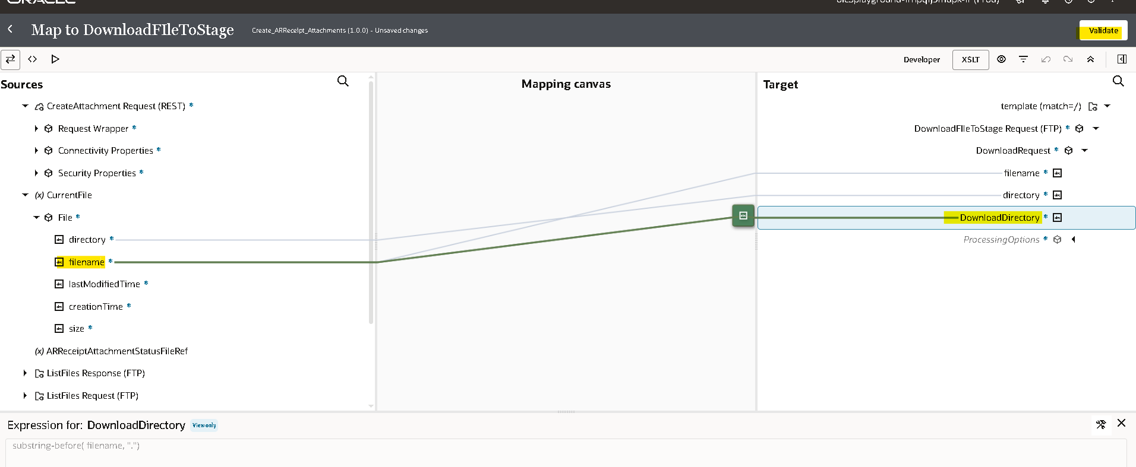

- Now we use Switch again to check if the Filename contains Credit or Receipt from the file name. This is done to check if file contains Receipts.
- For this drag and drop filename from Download file onto the condition box and use functions as shown below.
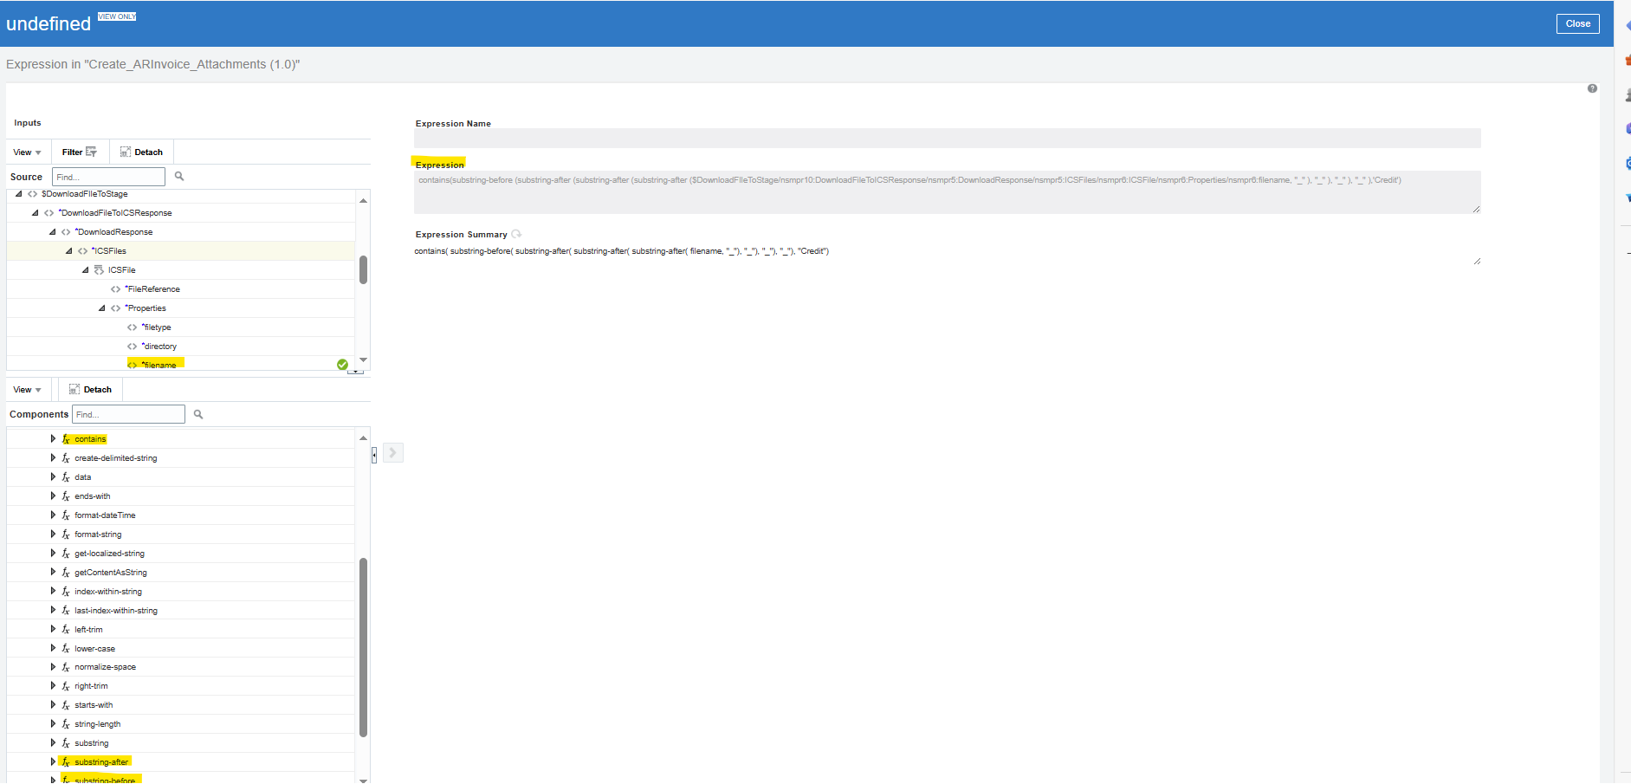

- Now we use Rest Connection (OIC_ERP_Rest_Conn) for getting Invoices.
- Select endpoint as GET and select parameters for this endpoint and response as shown in figure.
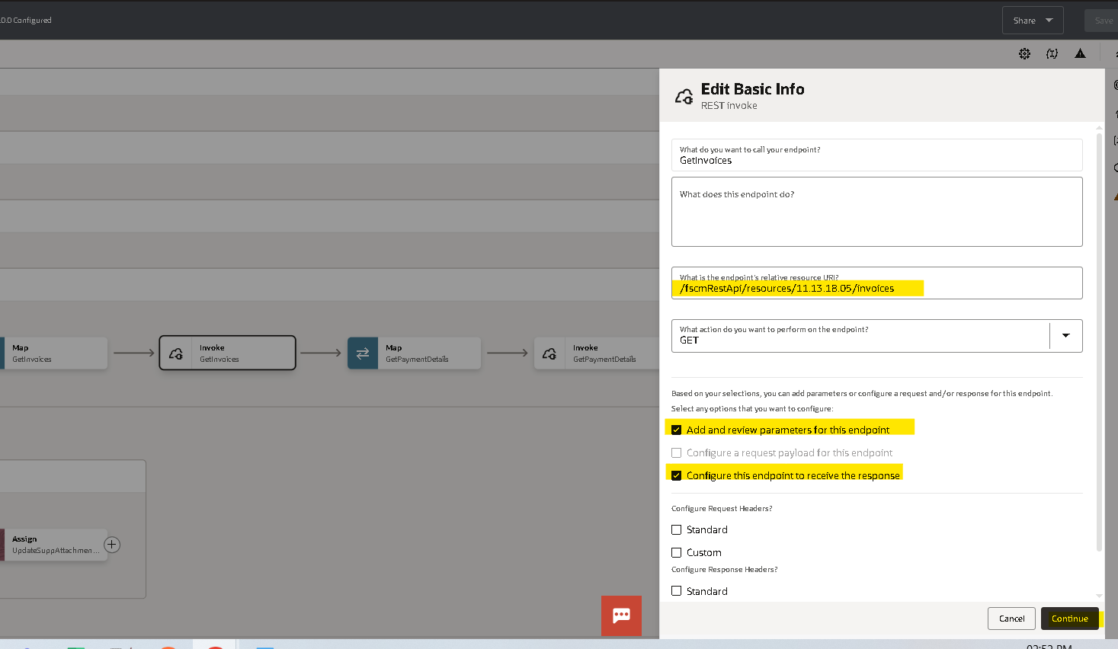

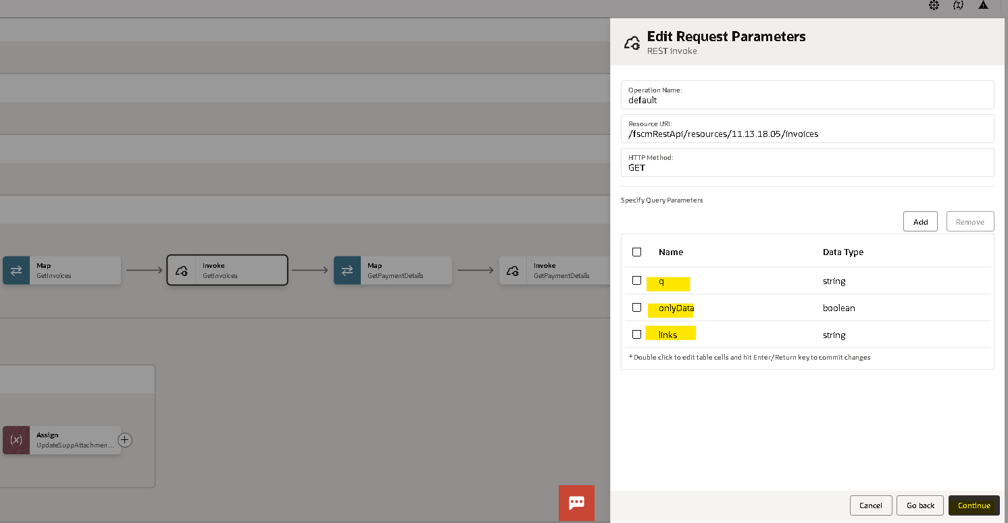
- Select Response payload format as JSON and click on inline to enter sample payload.

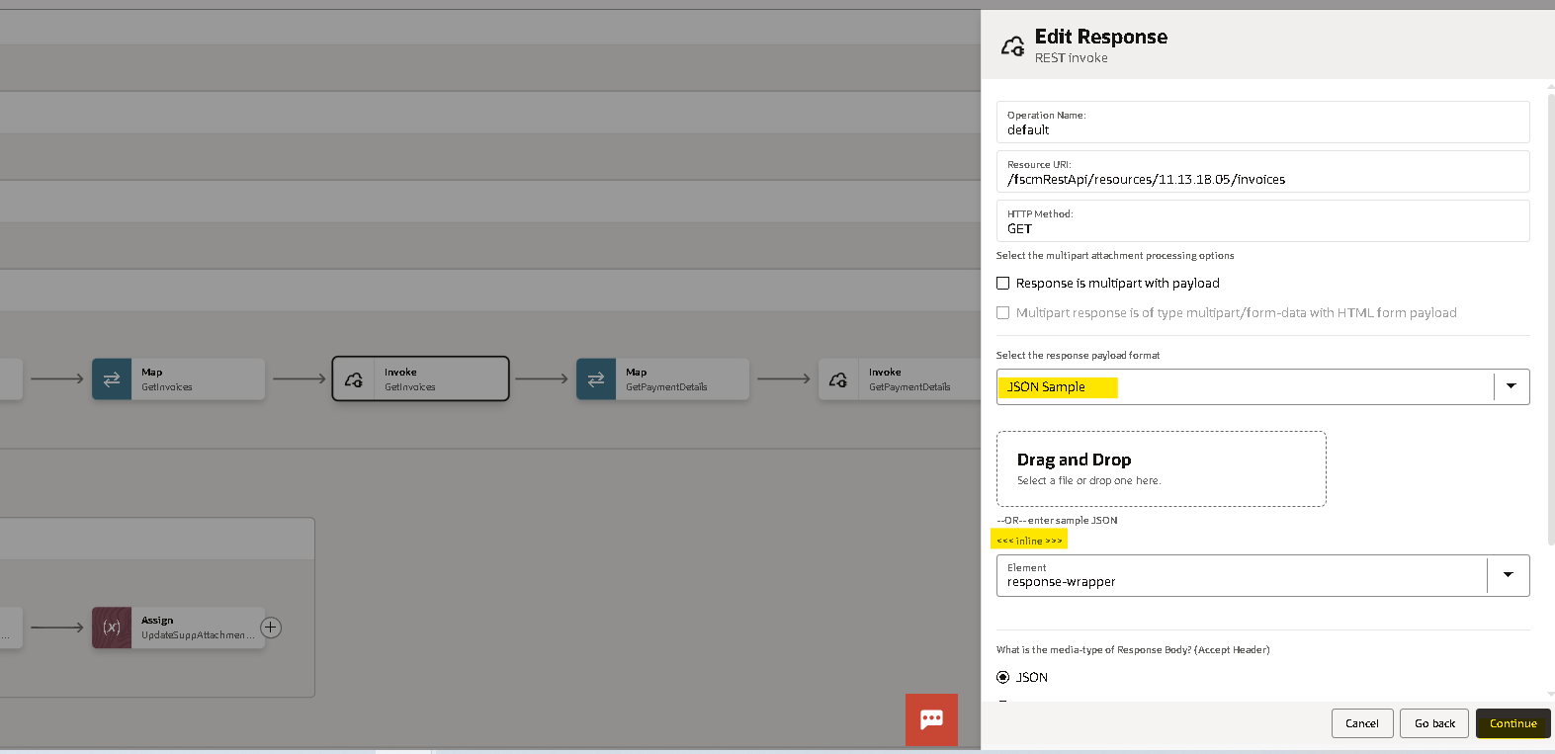

Sample Json Response:
{
"items" : [ {
"InvoiceId" : 300000003044308,
"InvoiceNumber" : "TEST02",
"InvoiceCurrency" : "EGP",
"PaymentCurrency" : "EGP",
"InvoiceAmount" : 400,
"InvoiceDate" : "2023-02-16",
"BusinessUnit" : "Emaar Misr for Development BU",
"Supplier" : "ANIMATION TEEM",
"SupplierNumber" : "10001",
"ProcurementBU" : null,
"SupplierSite" : "OFFICE",
"RequesterId" : null,
"Requester" : null,
"InvoiceGroup" : null,
"ConversionRateType" : null,
"ConversionDate" : null,
"ConversionRate" : null,
"AccountingDate" : "2023-02-16",
"Description" : "TEST02",
"DeliveryChannelCode" : null,
"DeliveryChannel" : null,
"PayAloneFlag" : false,
"InvoiceSourceCode" : "Manual Invoice Entry",
"InvoiceSource" : "Manual invoice entry",
"InvoiceType" : "Standard",
"PayGroup" : null,
"InvoiceReceivedDate" : null,
"PaymentReasonCode" : null,
"PaymentReason" : null,
"PaymentReasonComments" : null,
"RemittanceMessageOne" : null,
"RemittanceMessageTwo" : null,
"RemittanceMessageThree" : null,
"PaymentTerms" : "Immediate",
"TermsDate" : "2023-02-16",
"GoodsReceivedDate" : null,
"PaymentMethodCode" : null,
"PaymentMethod" : null,
"SupplierTaxRegistrationNumber" : null,
"FirstPartyTaxRegistrationId" : null,
"FirstPartyTaxRegistrationNumber" : null,
"LegalEntity" : "Emaar Misr for Development LE",
"LegalEntityIdentifier" : "111111111",
"LiabilityDistribution" : "01-901-91101-2121-31101001-01-000-0000-00000",
"DocumentCategory" : "STD INV - Standard Invoices",
"DocumentSequence" : 2,
"VoucherNumber" : null,
"ValidationStatus" : "Validated",
"ApprovalStatus" : "Not required",
"PaidStatus" : "Unpaid",
"AccountingStatus" : "Unaccounted",
"ApplyAfterDate" : null,
"CanceledFlag" : false,
"AmountPaid" : null,
"BaseAmount" : null,
"PurchaseOrderNumber" : null,
"Party" : "ANIMATION TEEM",
"PartySite" : "ADRS1",
"ControlAmount" : null,
"DocumentFiscalClassificationCodePath" : null,
"TaxationCountry" : "Egypt",
"RoutingAttribute1" : null,
"RoutingAttribute2" : null,
"RoutingAttribute3" : null,
"RoutingAttribute4" : null,
"RoutingAttribute5" : null,
"AccountCodingStatus" : "Not required",
"BudgetDate" : "2023-02-16",
"FundsStatus" : null,
"CanceledDate" : null,
"CanceledBy" : null,
"UniqueRemittanceIdentifier" : null,
"UniqueRemittanceIdentifierCheckDigit" : null,
"CreationDate" : "2023-02-16T09:26:22.001+00:00",
"CreatedBy" : "mohamed_ghazy@rayais.com",
"LastUpdatedBy" : "mohamed_ghazy@rayais.com",
"LastUpdateDate" : "2023-09-12T08:29:20.277+00:00",
"LastUpdateLogin" : "020E748283E1E471E063A951410A211F",
"BankAccount" : null,
"SupplierIBAN" : null,
"ExternalBankAccountId" : null,
"BankChargeBearer" : null,
"SettlementPriority" : null,
"ReferenceKeyOne" : null,
"ReferenceKeyTwo" : null,
"ReferenceKeyThree" : null,
"ReferenceKeyFour" : null,
"ReferenceKeyFive" : null,
"ProductTable" : null,
"ImageDocumentNumber" : null
} ],
"count" : 1,
"hasMore" : false,
"limit" : 25,
"offset" : 0,
"links" : [ {
"rel" : "self",
"href" : "https://fa-ewtd-test-saasfaprod1.fa.ocs.oraclecloud.com:443/fscmRestApi/resources/11.13.18.05/invoices",
"name" : "invoices",
"kind" : "collection"
} ]
}
- Click on continue.
- Now in mapper of REST, map as follows.
- Assign true as value for Only Data and assign q parameter to InvoiceNumber=’$invoiceNumber’ .Click on Validate.
  - concat ("InvoiceNumber=", substring-before (substring-after (substring-after ($CurrentFile/nsmpr0:File/nsmpr0:filename, "$" ), "$" ), "$" )
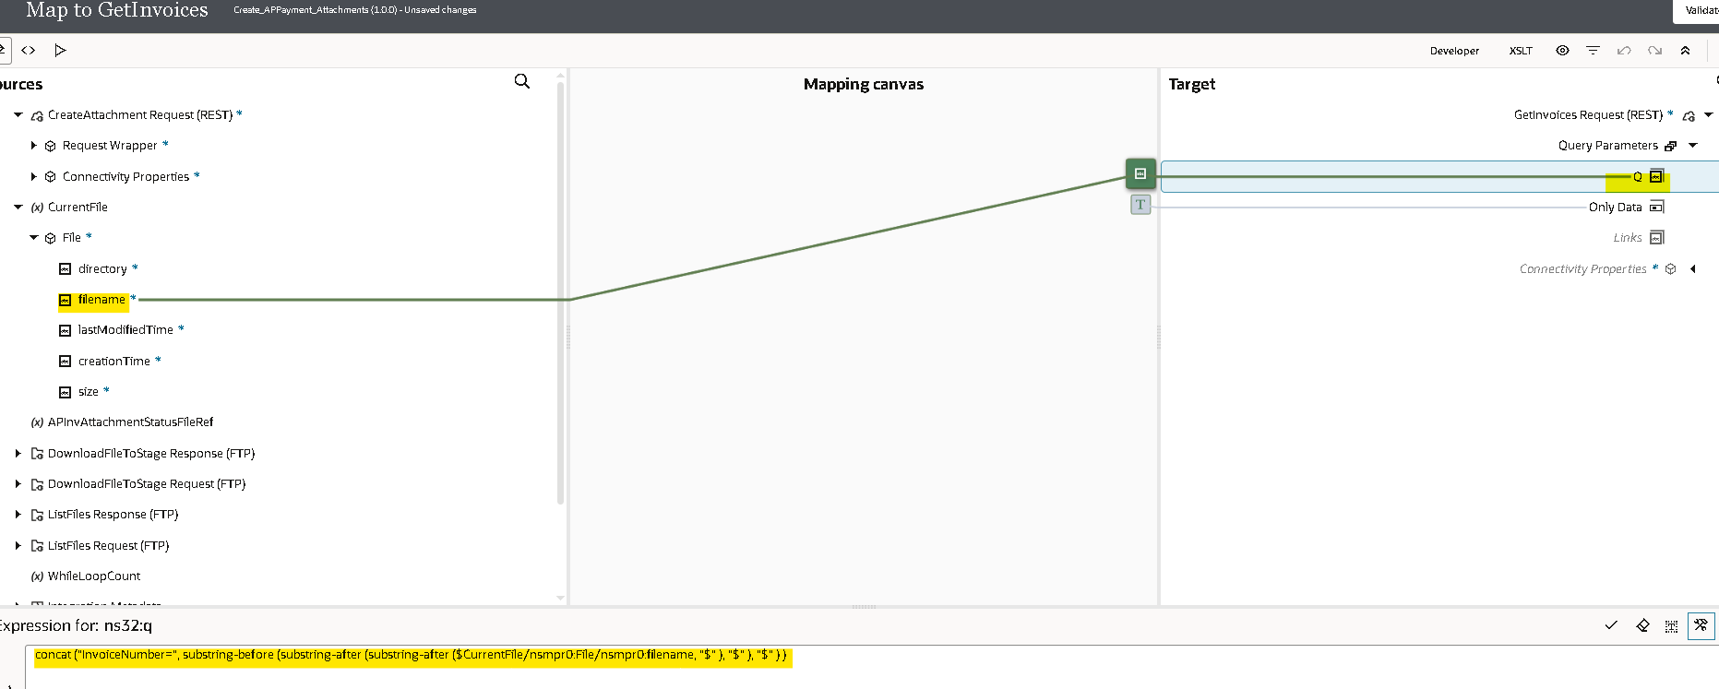
- Now we will use rest api to get Ap Payments.
- Select endpoint as GET and select parameters for this endpoint and response as shown in figure.
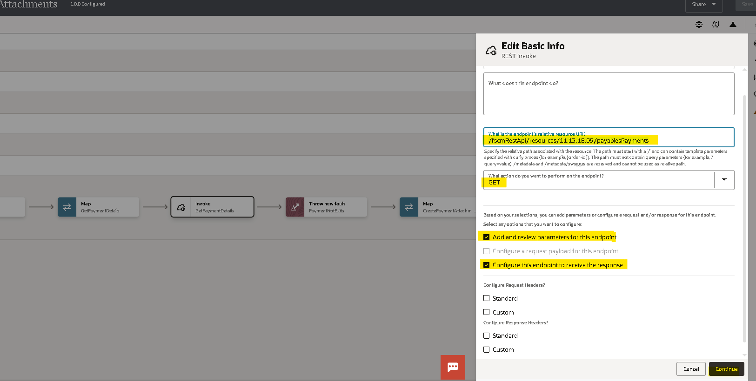
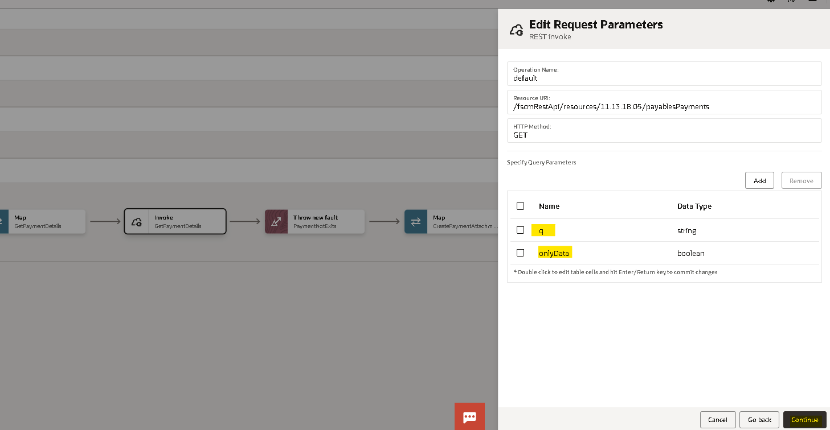

- Select Response payload format as JSON and click on inline to enter sample payload and click on Continue
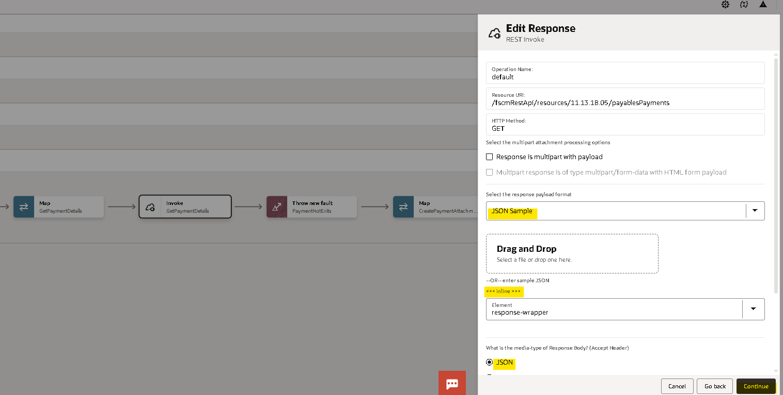

Sample Respond Payload :
{
"items" : [ {
"CheckId" : 300000021702298,
"PaymentId" : 73005,
"PaymentReference" : 186,
"PaperDocumentNumber" : 100,
"PaymentNumber" : 100,
"PaymentFileReference" : 70005,
"PaymentProcessRequest" : "Quick payment: ID=300000021702298",
"PaymentAmount" : 5000,
"PaymentDate" : "2024-06-26",
"AccountingDate" : "2024-06-26",
"PaymentDescription" : null,
"ConversionRate" : null,
"ConversionDate" : null,
"ConversionRateType" : null,
"ClearingDate" : null,
"ClearingAmount" : null,
"ClearingLedgerAmount" : null,
"ClearingConversionRate" : null,
"ClearingConversionDate" : null,
"ClearingConversionRateType" : null,
"CrossCurrencyRateType" : "Corporate",
"MaturityDate" : null,
"MaturityConversionRateType" : null,
"MaturityConversionDate" : null,
"MaturityConversionRate" : 1,
"AnticipatedValueDate" : null,
"ClearingValueDate" : null,
"StopDate" : null,
"VoidDate" : null,
"VoidAccountingDate" : null,
"PaymentStatus" : "Negotiable",
"SeparateRemittanceAdviceCreated" : null,
"AccountingStatus" : "Unaccounted",
"ReconciledFlag" : false,
"PaymentType" : "Quick",
"PaymentCurrency" : "EGP",
"WithheldAmount" : null,
"BankChargeAmount" : null,
"LegalEntity" : "Emaar Misr for Development LE",
"BusinessUnit" : "Emaar Misr for Development BU",
"PaymentFunction" : null,
"Payee" : "BELLA VITA (CURTIAN SHOP)",
"PartyId" : 300000003241004,
"ProcurementBU" : null,
"PayeeSite" : "OFFICE Project",
"EmployeeAddress" : null,
"SupplierNumber" : "10022",
"ThirdPartySupplier" : null,
"ThirdPartyAddressName" : null,
"ExternalBankAccountId" : null,
"RemitToAccountNumber" : null,
"DisbursementBankAccountNumber" : "XXXXXX05-1",
"DisbursementBankAccountName" : "Al Alamian",
"PaymentMethodCode" : "CHECK",
"PaymentMethod" : "Check",
"PaymentDocument" : "Check Payment",
"PaymentProcessProfileCode" : "EM_PPP",
"PaymentProcessProfile" : "EM_PPP",
"DocumentCategory" : "Electronic Payments",
"DocumentSequence" : "EMD_PAYMENTS_2024",
"VoucherNumber" : 124000038,
"PaymentBaseAmount" : null,
"PaymentBaseCurrency" : "EGP",
"AddressLine1" : null,
"AddressLine2" : null,
"AddressLine3" : null,
"AddressLine4" : null,
"City" : null,
"County" : null,
"Province" : null,
"State" : null,
"Country" : "EG",
"Zip" : null,
"CreatedBy" : "islam_refaat@rayais.com",
"CreationDate" : "2024-06-26T12:24:33+00:00",
"LastUpdatedBy" : "Data_Migration",
"LastUpdateDate" : "2024-06-27T07:00:27.625+00:00",
"LastUpdateLogin" : "198E8E5DD91A73ECE063A951410A337B",
"StopReason" : null,
"StopReference" : null
} ],
"count" : 1,
"hasMore" : false,
"limit" : 25,
"offset" : 0,
"links" : [ {
"rel" : "self",
"href" : "https://fa-ewtd-test-saasfaprod1.fa.ocs.oraclecloud.com:443/fscmRestApi/resources/11.13.18.05/payablesPayments",
"name" : "payablesPayments",
"kind" : "collection"
}, {
"rel" : "action",
"href" : "https://fa-ewtd-test-saasfaprod1.fa.ocs.oraclecloud.com:443/fscmRestApi/resources/11.13.18.05/payablesPayments/action/initiateStopPayment",
"name" : "initiateStopPayment",
"kind" : "other"
} ]
}
- Open Mapper of the rest adapter Assign true as value for Only Data and assign q parameter to Checkid=’$checkid’. Click on Validate.
  - concat ("CheckId=", substring-before (substring-after ($CurrentFile/nsmpr0:File/nsmpr0:filename, "$" ), "$" ) )
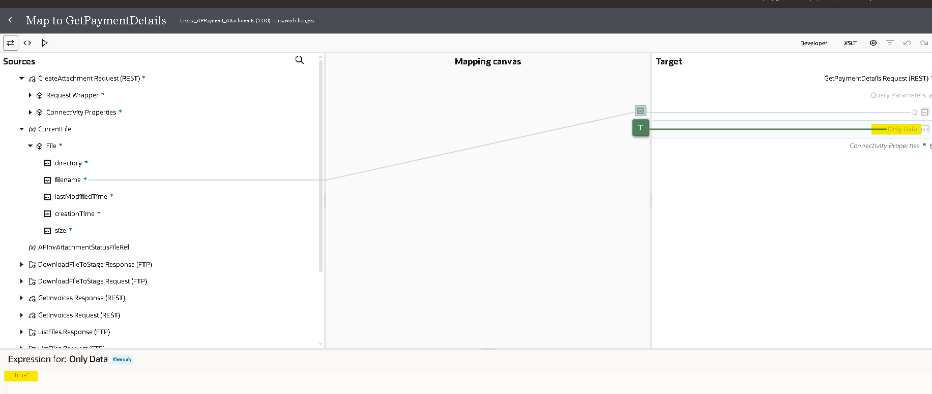

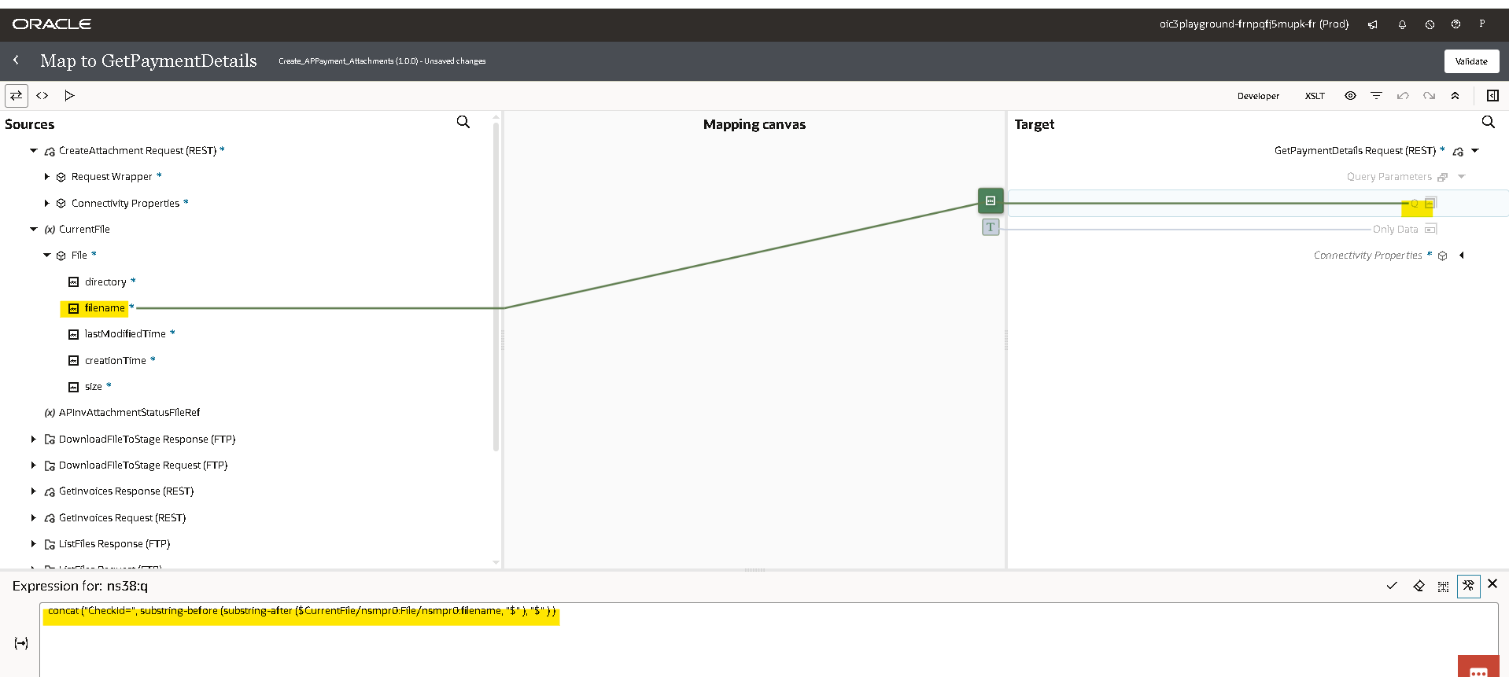

- Use throws new fault to raise custom fault based on payment count. And add the skip Condition.
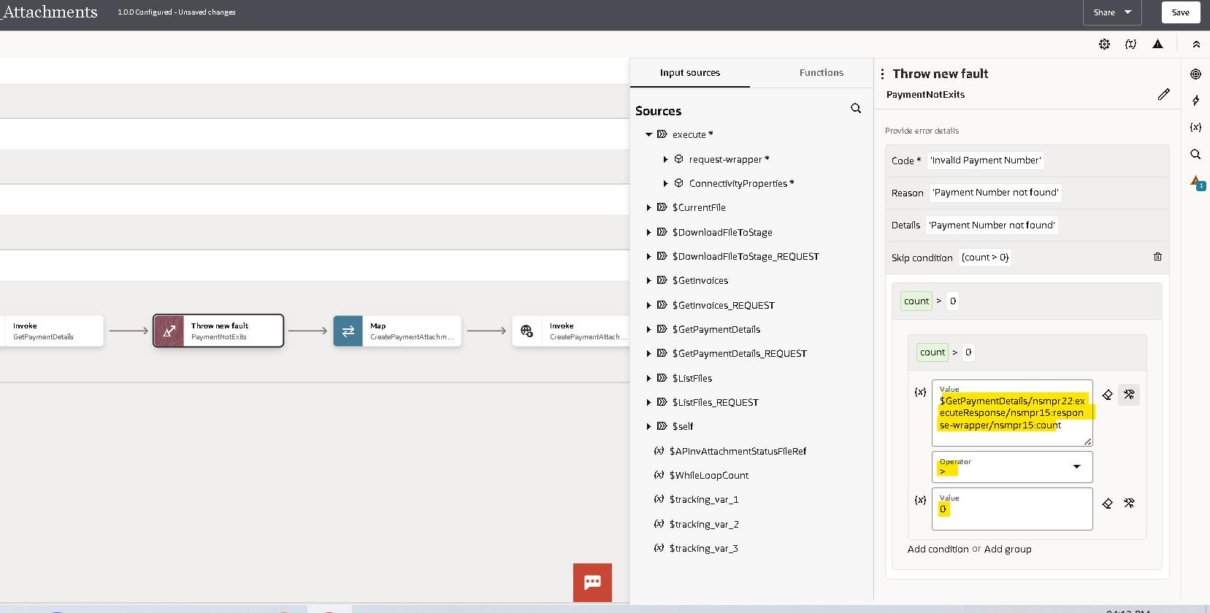

- We will use Soap Adapter to upload attachments to fusion.

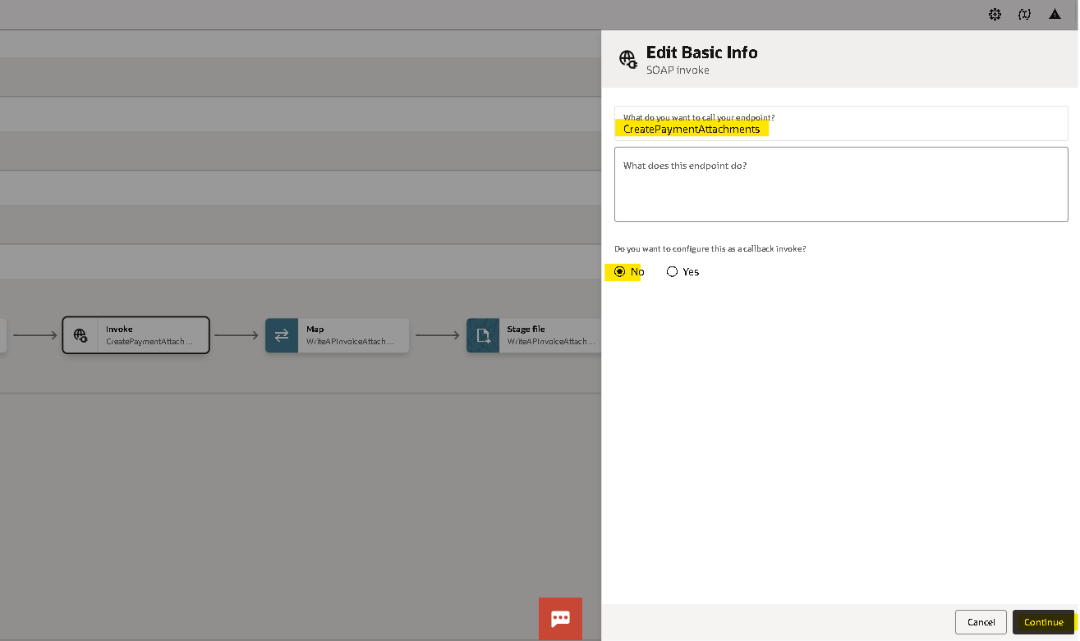
- Select the Operation as upload attachments. click on continue and finish.
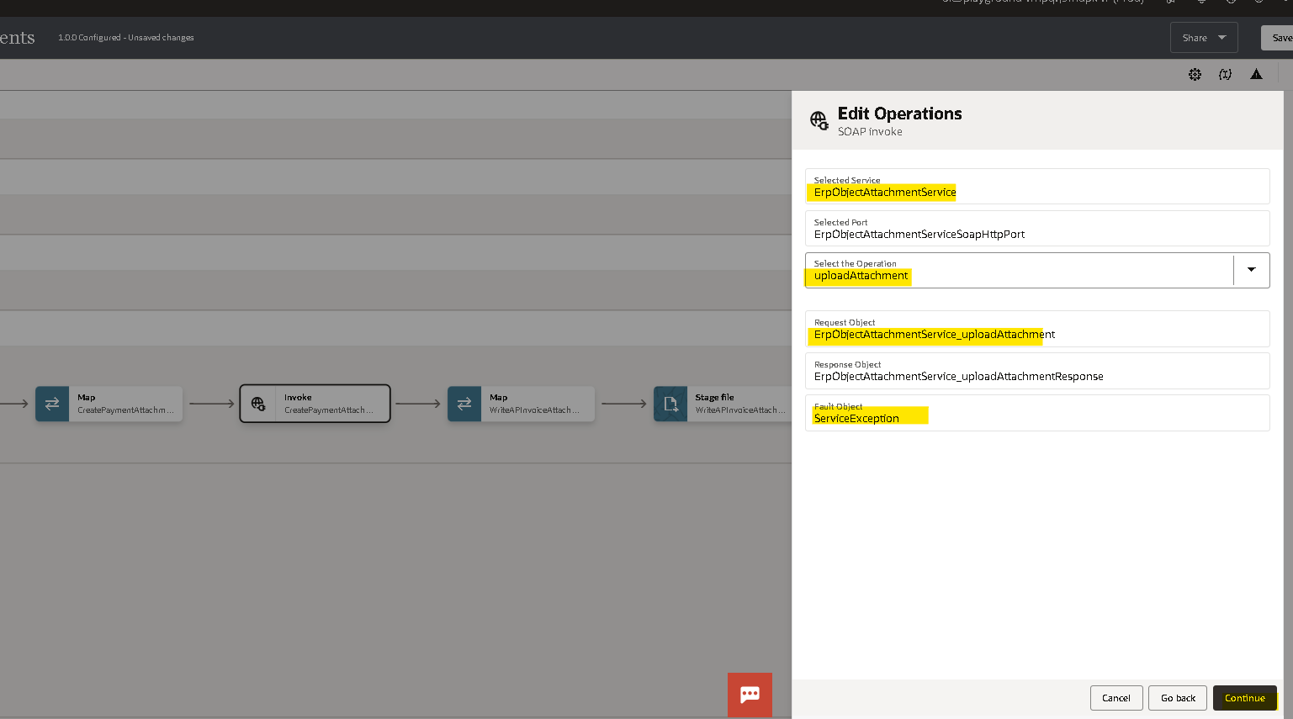

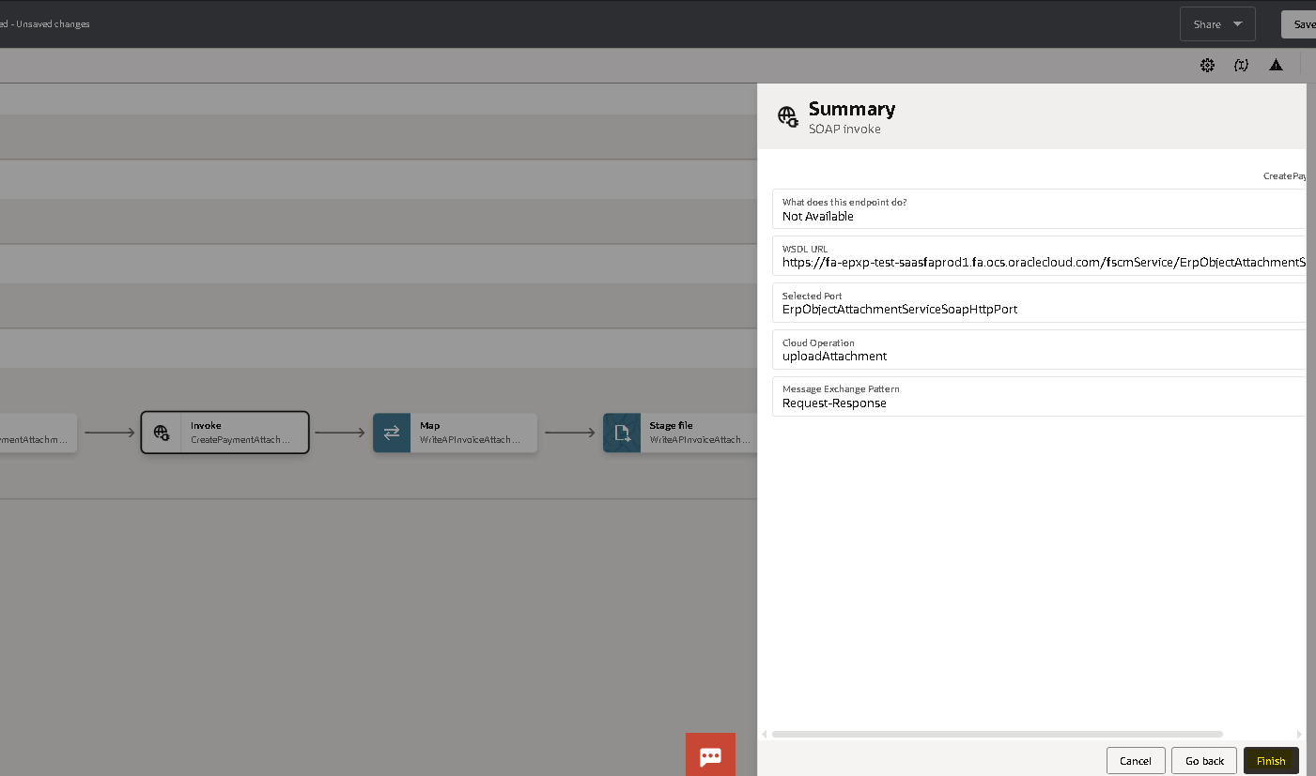

- Edit the mapper and hardcode the values for below fields.
  - Assign entityname = AP_CHECKS_ALL"
  - Category name= "PAYMENT_SUPPORTING_DOC"
  - Allow duplicate = "yes"
  - Attachment type=’File’
- Assign payment reference for userkeyA
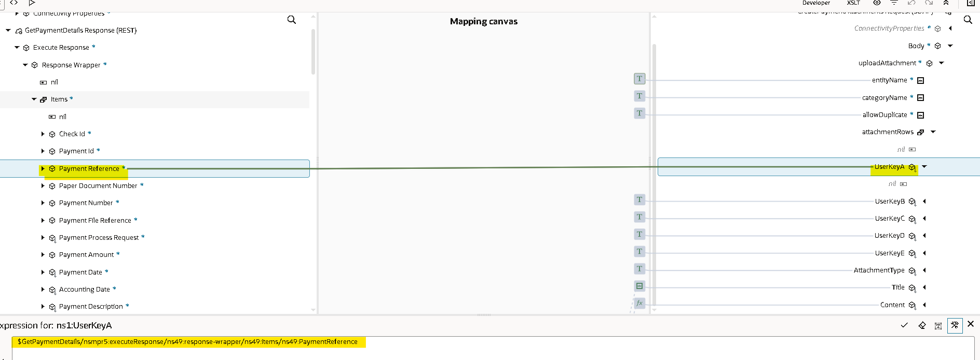
- use substring to map the file name to title.
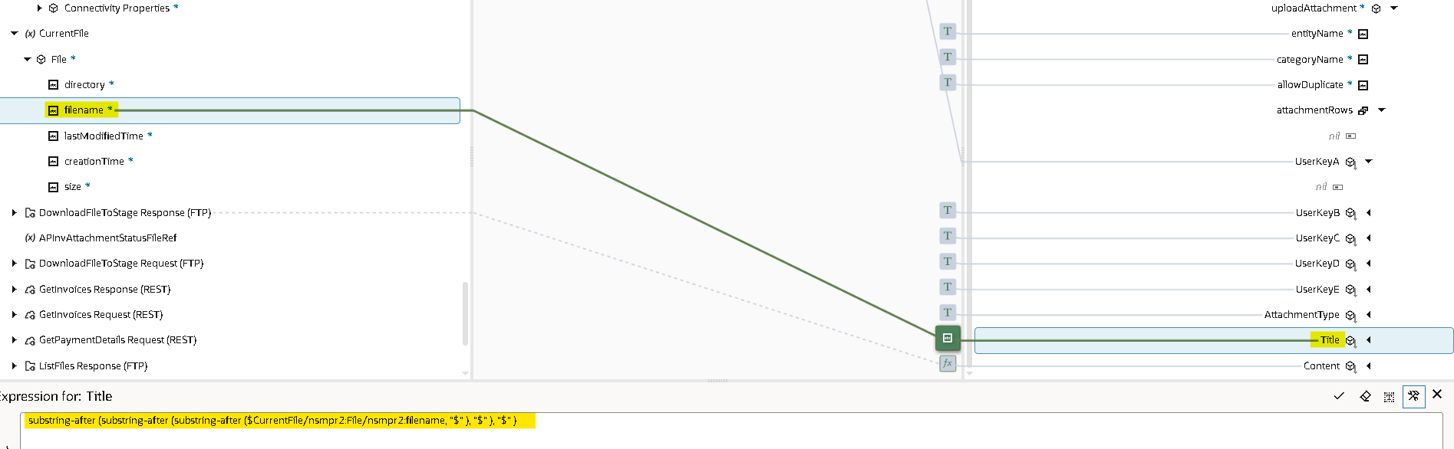
- for content use encodetobase64 operation to encode content to base64 as shown in figure and #Null for remaining fields and validate.
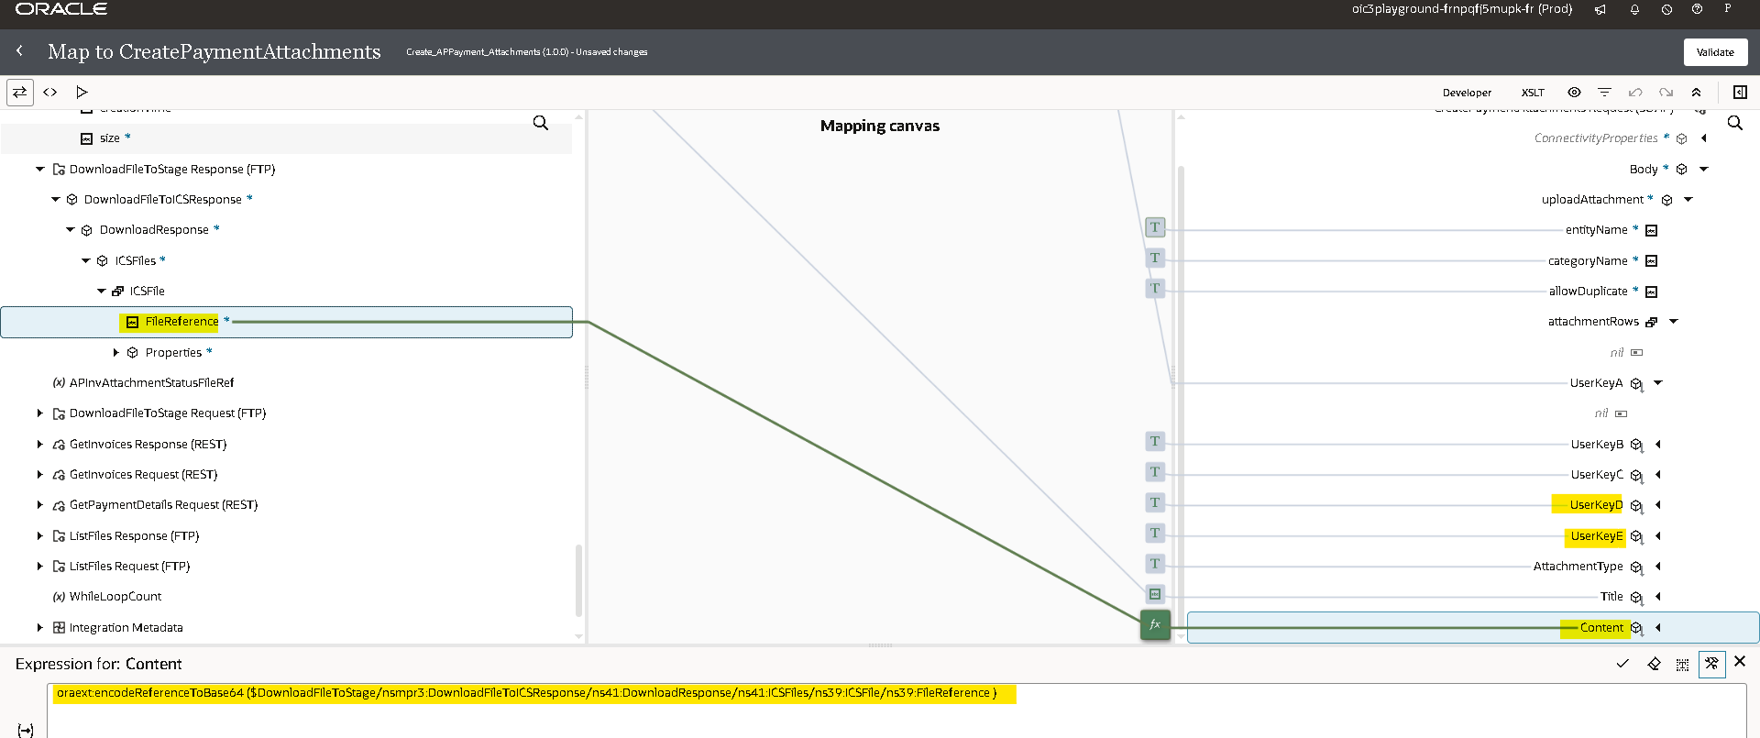

- Now we use Stage Write Operation to write the Attachment Status File. Use concat function with WhileLoopCount variable for Output Directory. Specify a CSV file for structure of the file to be written.
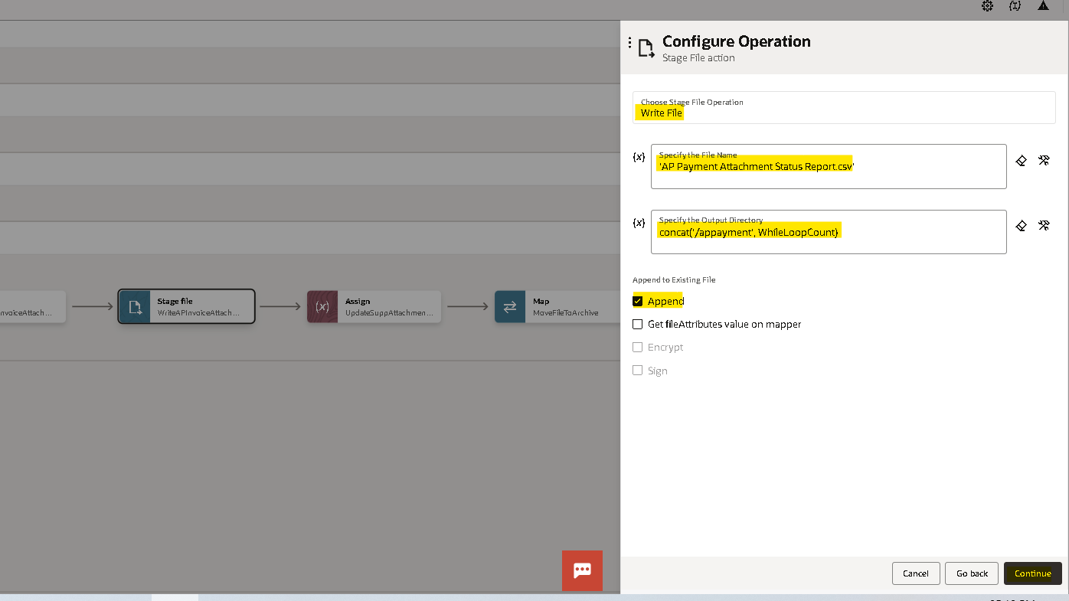

- Select sample file format as CSV.
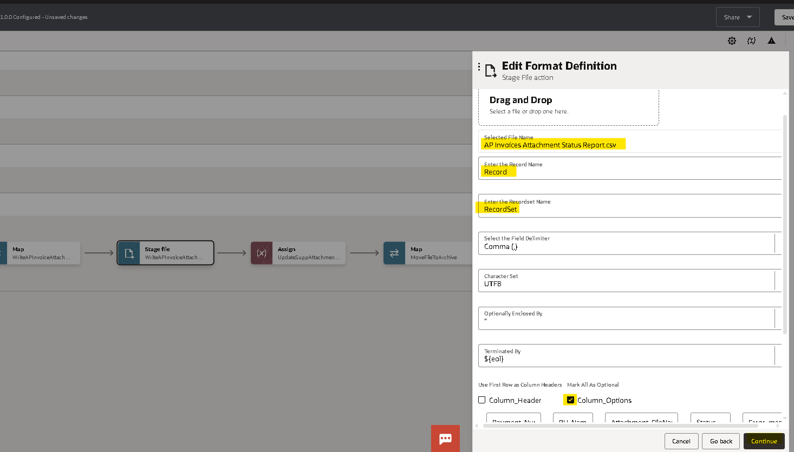

- Recheck the details and click on finish.
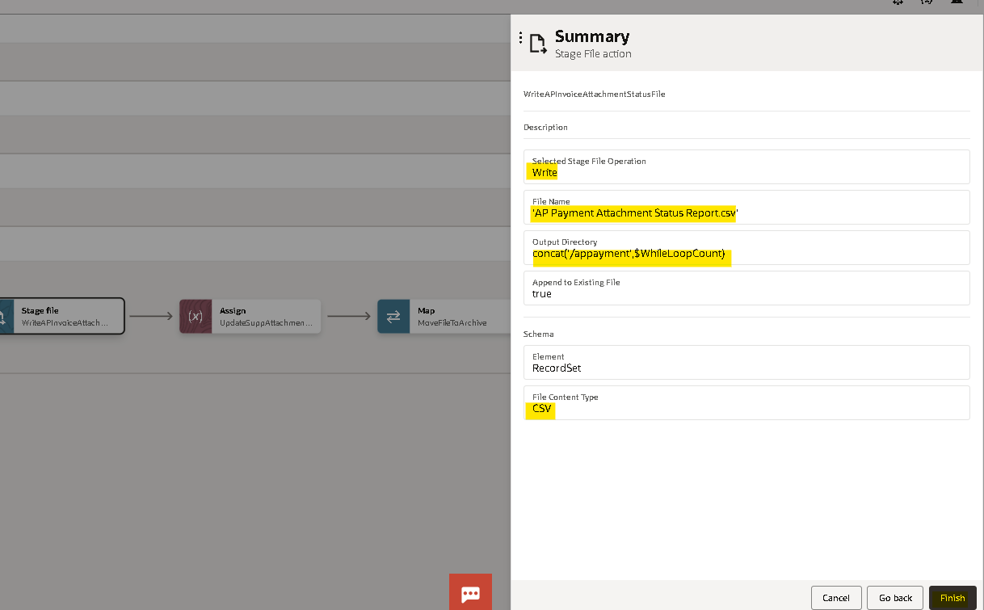

- Now in the mapper of Stage Write, map as shown below. Use the choose function to manage the status filed based on soap response.
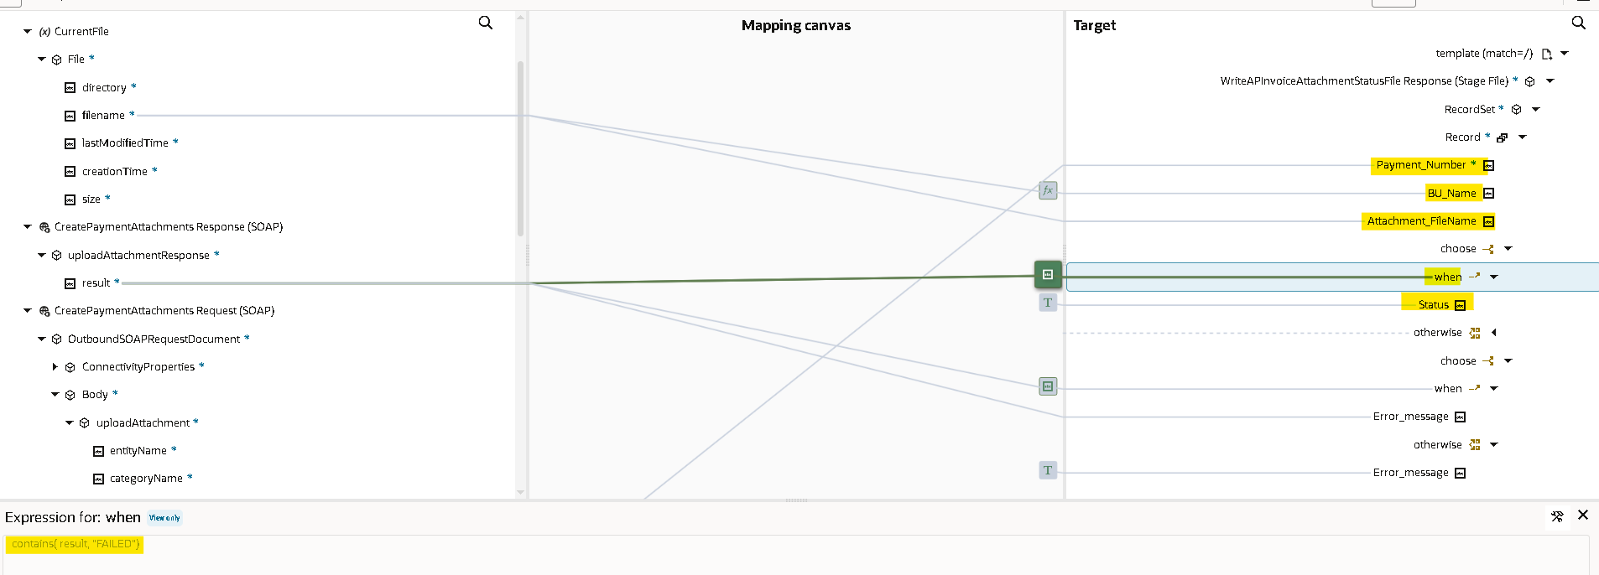

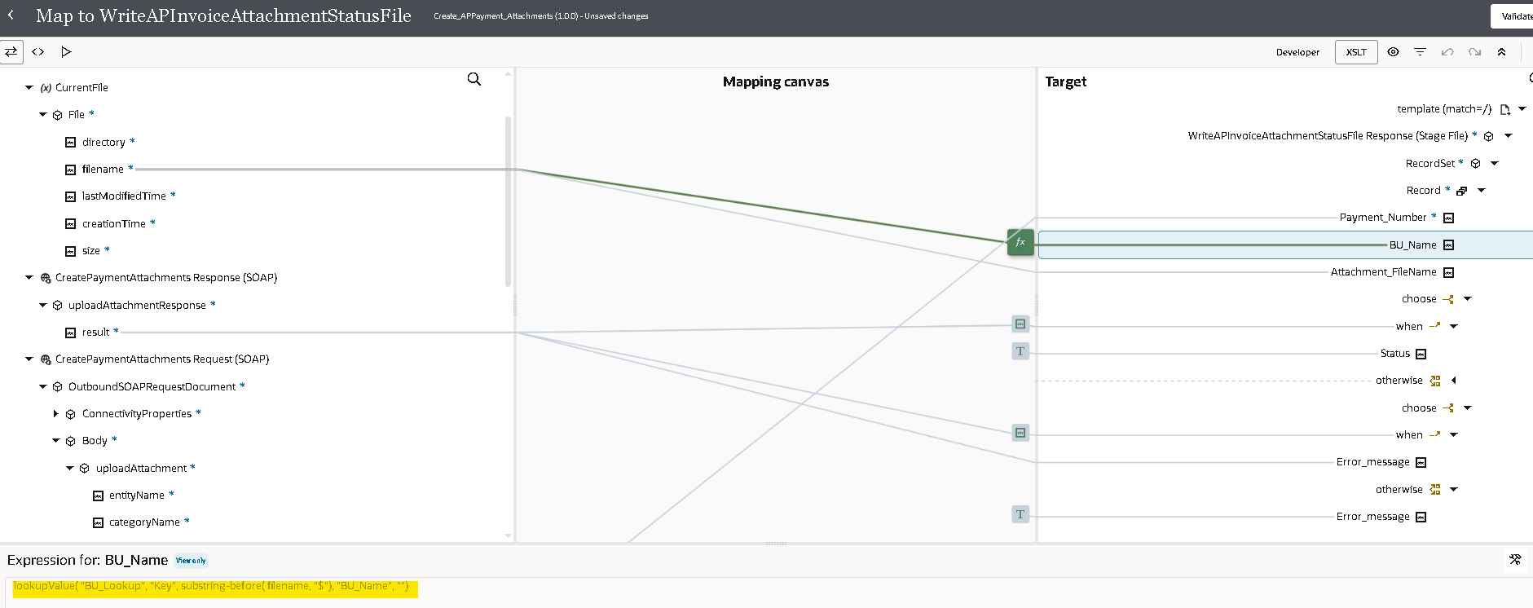

- For Mapping BU_Name with filename, create a target node at BU_Name. Here we are using ‘BU_Lookup’ Lookup. In this Lookup we have taken Source column as ‘Key’ and Target column as ‘BU_Name’ and default value as Null as shown below.

- Now update APpaymentsAttachmentStatusFileRef variable for ‘Success’ by using Assign operation.

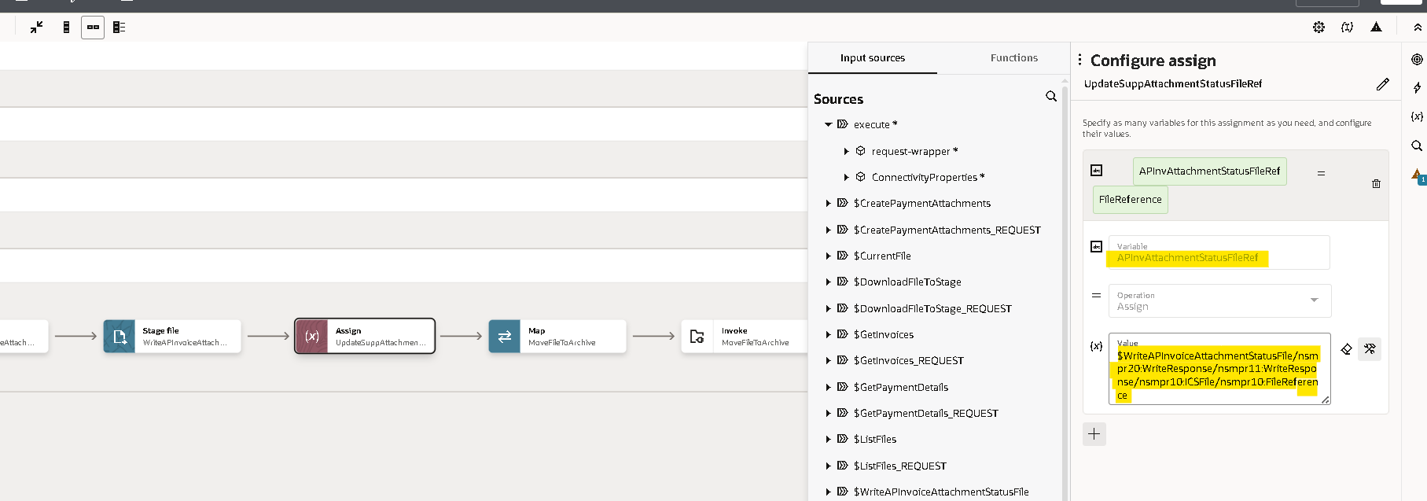

- Now to Archive the file, we use Stage Move operation.
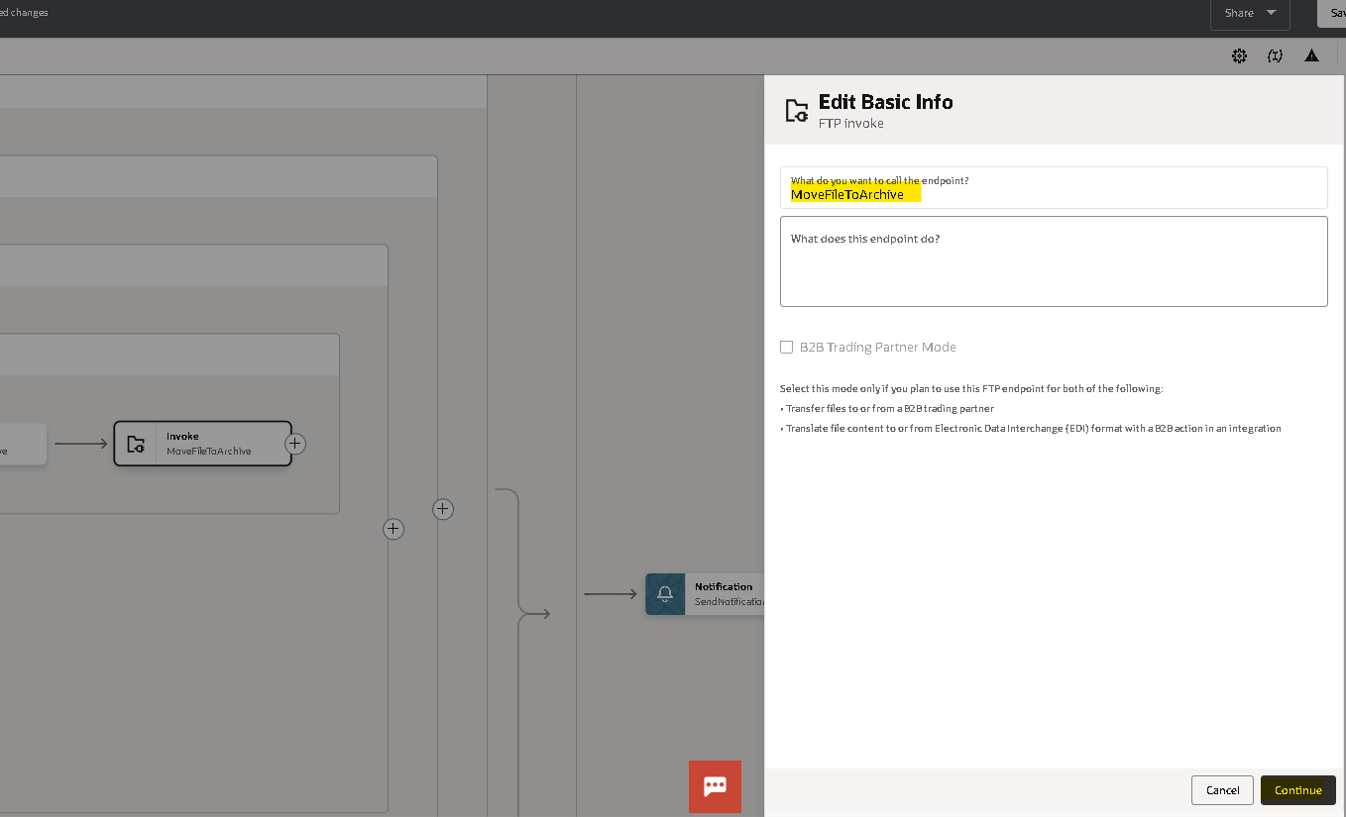

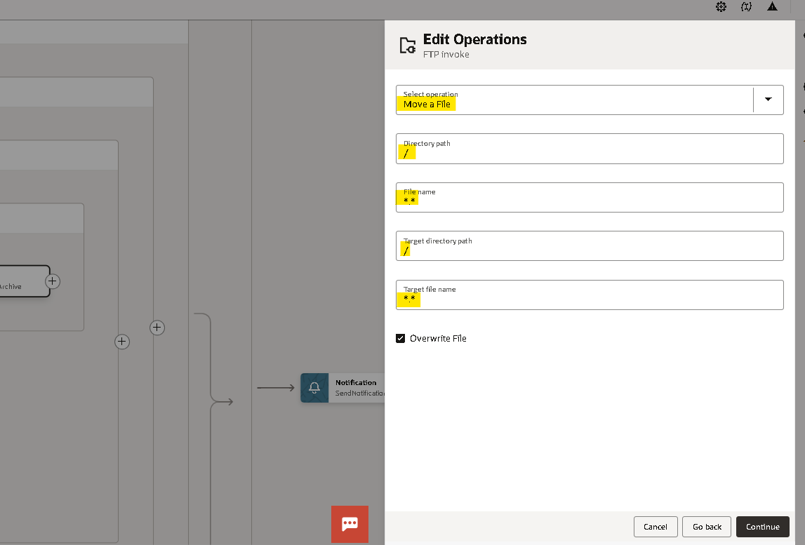

- Now in the mapper of Move operation, map as shown below.
- Click on XSLT, and use Choose, When, otherwise functions to archive file to a particular directory as we did in starting for a particular BU_ID.

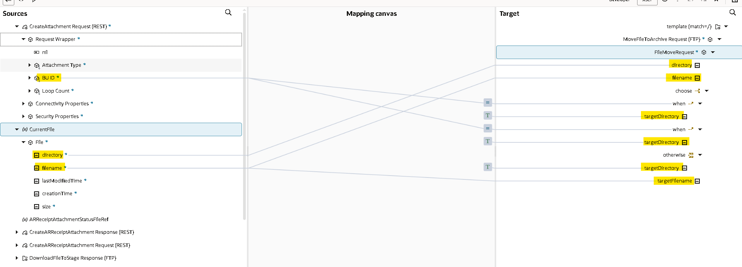

- Repeat the same procedure for all BU_IDs.

- Now click on Fault Handler of the Scope and click on the Default Handler popup.
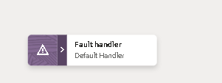
- Now we need to handle the fault handler for the ScopeForEachFile
- We will use default handler to be processed if any error occurs.
- To write an Error file, click on the ‘+’ icon and search and select Stage file operation.
- Enter a name.

- Now select Write File as the Stage File Operation.
- Specify the file name and use concat function with WhileLoopCount variable for output directory as shown below.
- Check the Append to Existing File.
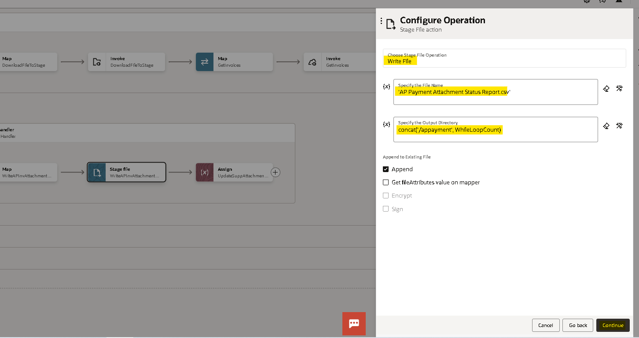

- We need to give sample structure format for the file.
- Now choose a file having the format in which you want to write the Error file.

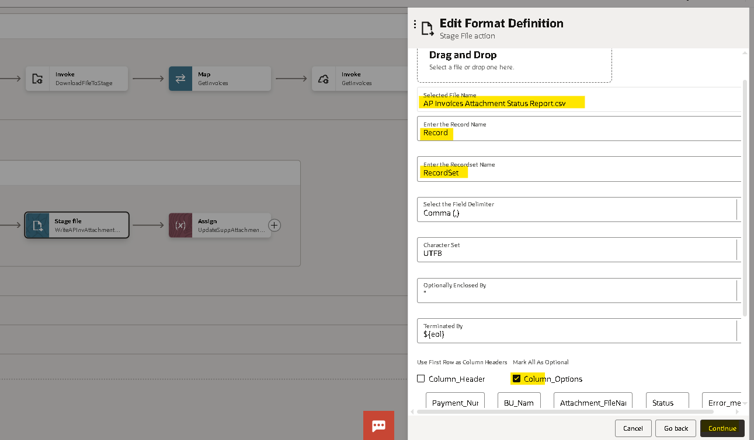

- After choosing a file, Enter Record Name and Recordset Name.
- Now in the mapper of Write Stage operation, map as shown below.
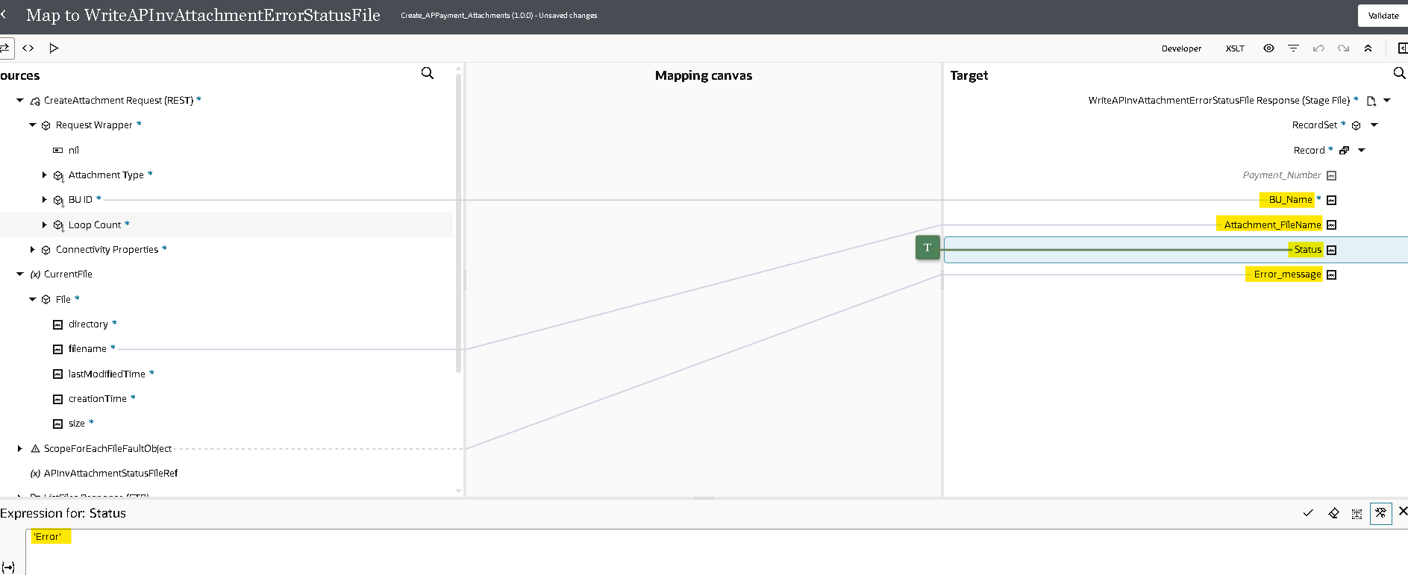

- For Mapping BU_Name with filename, create a target node at BU_Name. Here we are using ‘BU_Lookup’ Lookup. In this Lookup we have taken Source column as ‘Key’ and Target column as ‘BU_Name’ and default value as Null as shown below.
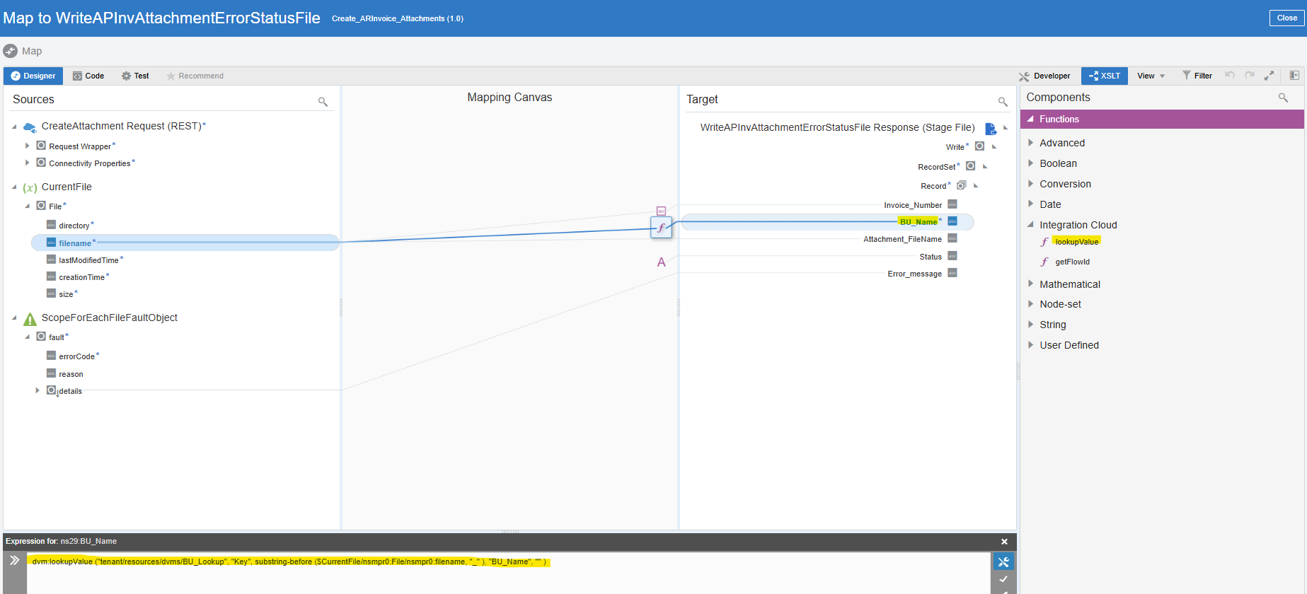

- Now update APpaymentsAttachmentStatusFileRef variable for ‘Error’ by using Assign operation.
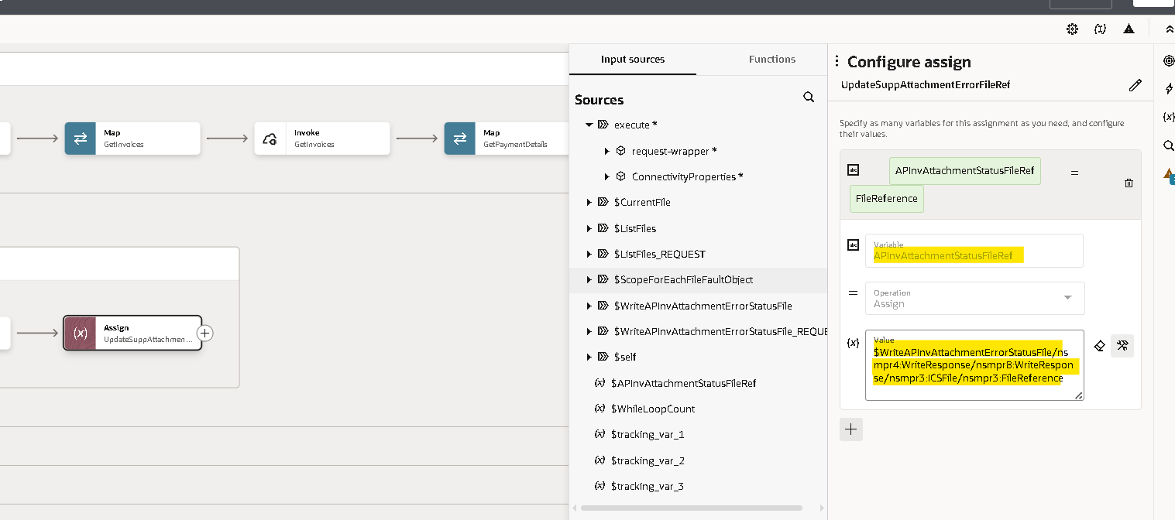

- Now click here to exit Fault Handler.
- Now we will use the notification activity to send a mail in message body we will send the InstanceId of the integration
- Now click on ‘+’ icon and search and select Notification to send notifications to concerned people once the integration is complete.

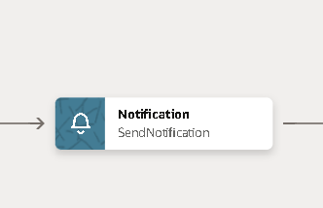
- Now, enter the From and To Email addresses, enter the subject. Select attachments.
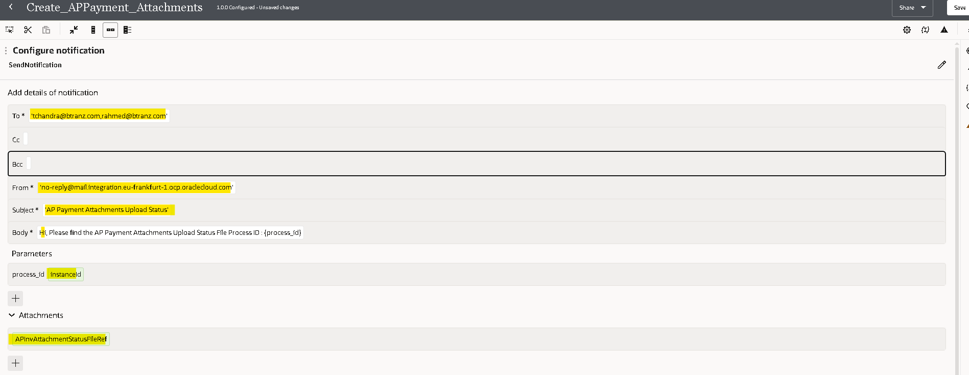
- In the Body, you can enter a parameter by writing in {process_id} format. Then select the parameter value as instance id as shown below.
- Now use Assign operation to create a variable in order to update the WhileLoopCount variable to exit the while loop.
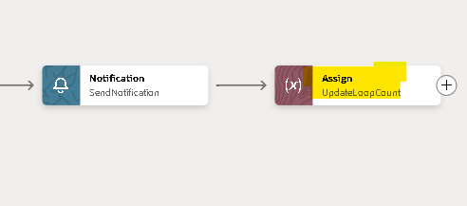
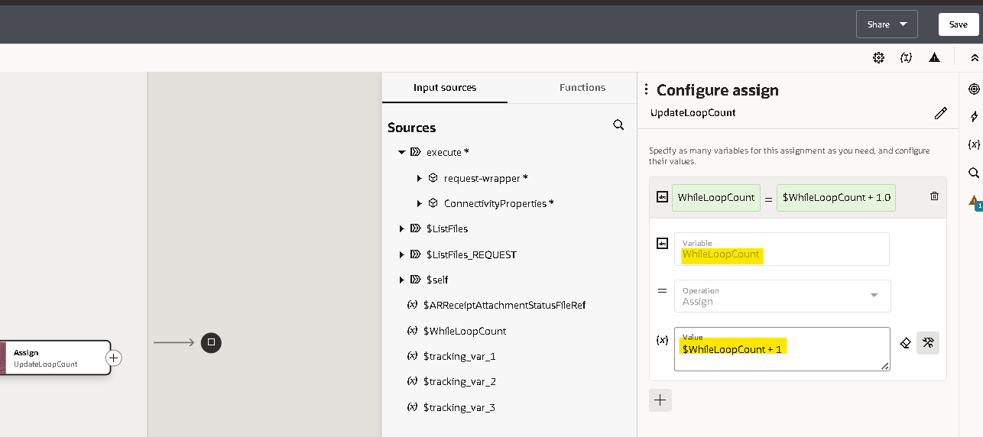

- For every integration we need to assign at least one tracking variable maximum we can assign up to three as it will be used when we are tracking the integration. here you can observe the error.

- Drag any variable from source to tracking field to mention it as primary variable. And hit Save.
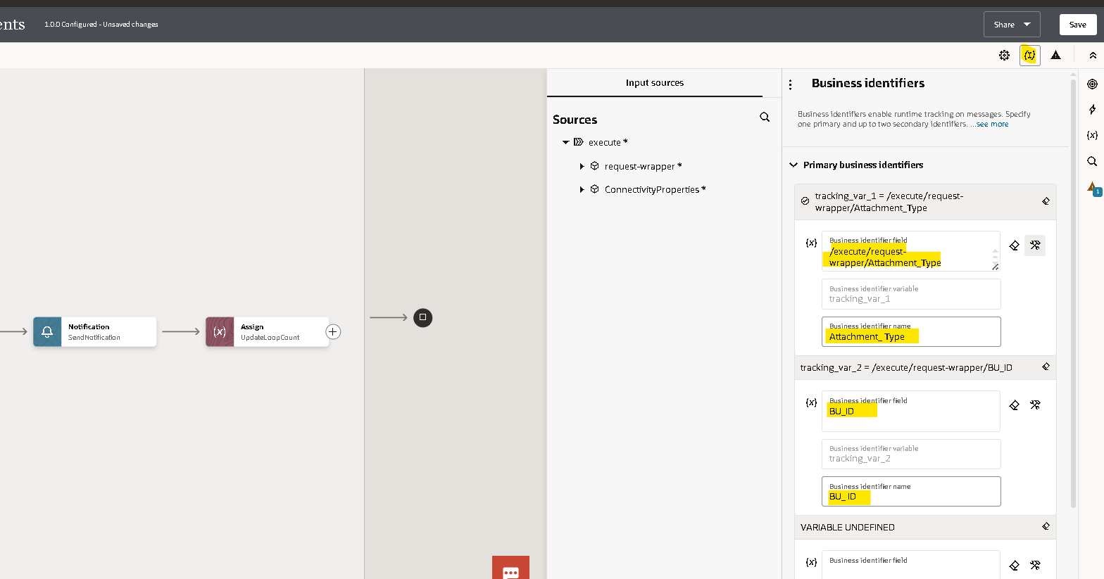
- Once you declare the tracking variable save and close the integration.
Running An Integration:

- Before running an integration, we need to activate it initially it will be in draft state after successful creation it will be in configured state after activating it will be in active state.
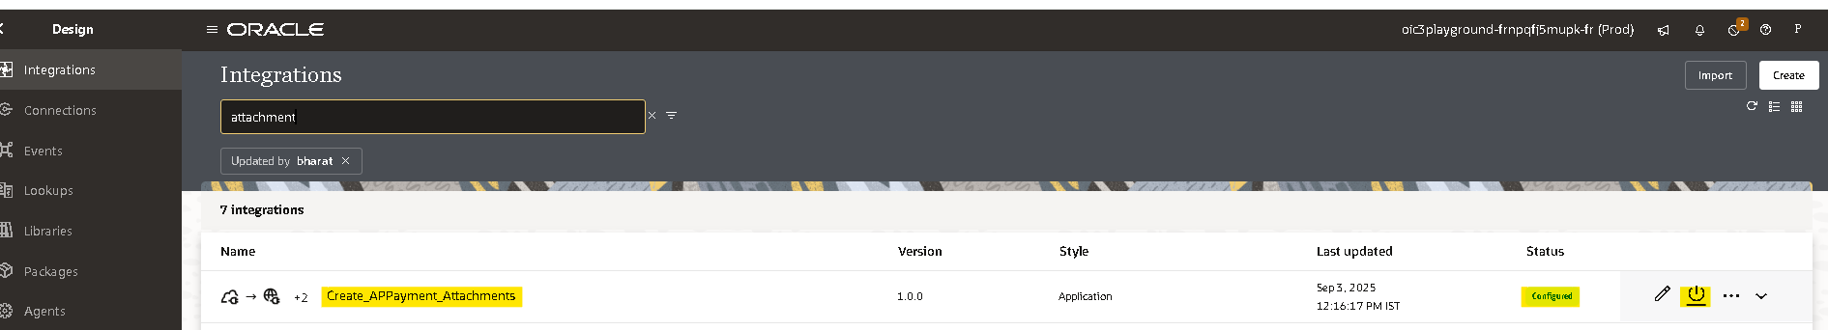
- You can activate and schedule as per your requirement it will run if the integration type is schedule, or you can just activate directly.
- By checking include payload option it helps you to check the payload of each operation in tracking page.

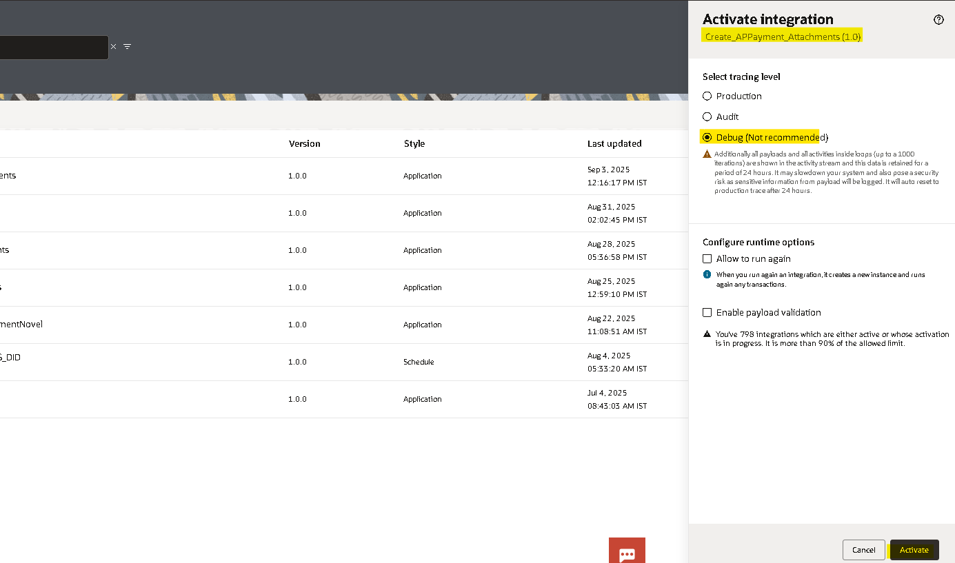
- By clicking on submit now option it will run the integration.
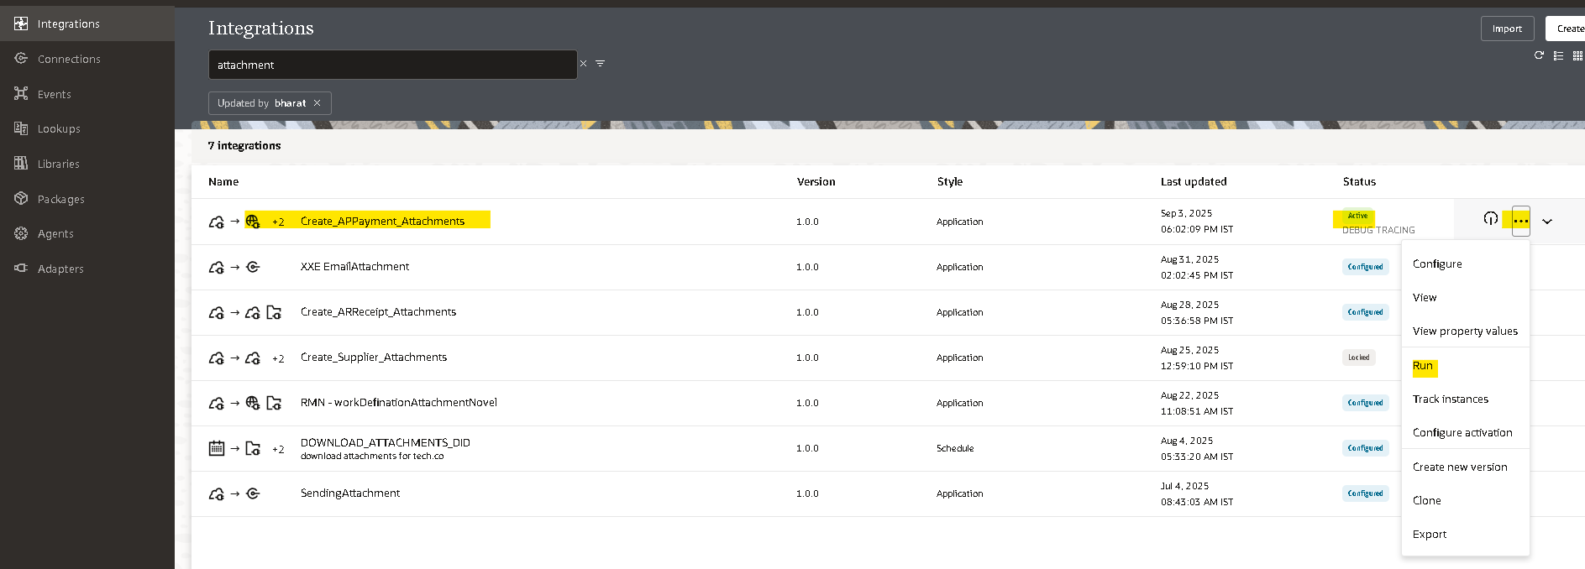

- You will get an InstanceId when you run the integration by clicking on that instance id you will be redirect to tracking page where you can check the status of that integration.
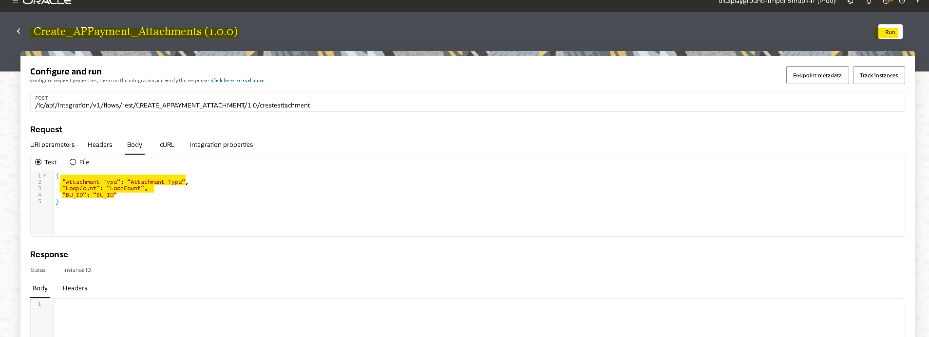

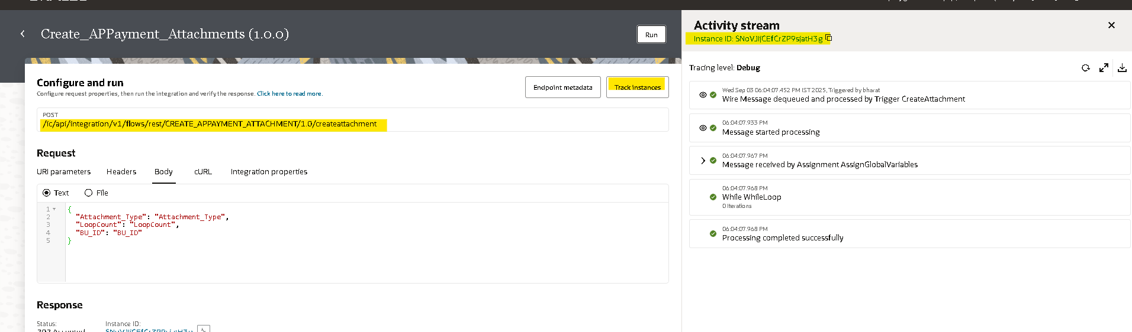

Tracking The Integration: 

- To track the integration manually ObservabilityInstances
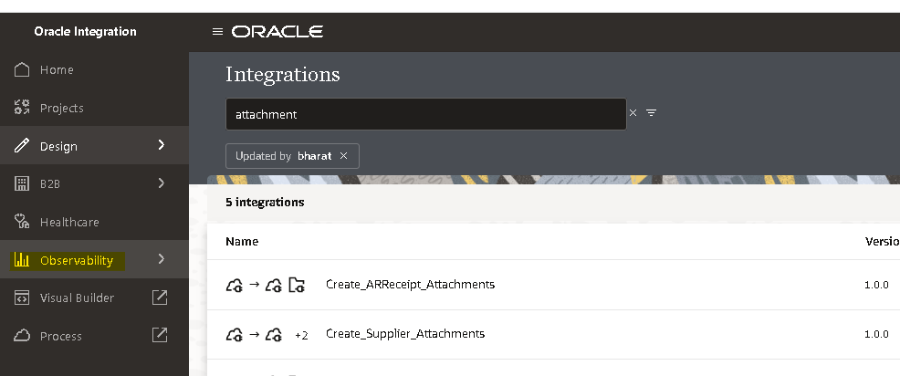

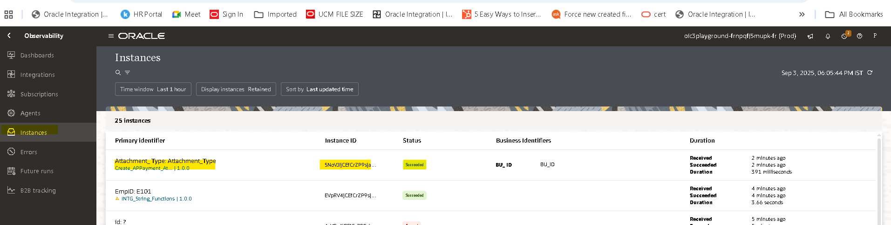

- Here you can observe the InstanceId and status of the integration (if you clicked on instanceid while running the integration you will be redirected here)
- By clicking on instance id in activity stream you can check the flow of the integration.
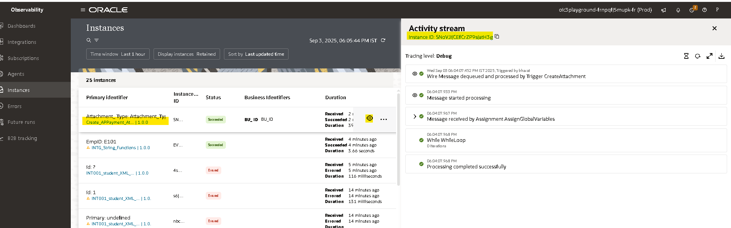

Open and Closed Issues for this Deliverable

Open Issues

ID | Issue | Resolution | Responsibility | Target Date | Impact Date

Closed Issues

ID | Issue | Resolution | Responsibility | Target Date | Impact Date

